IBIS
- LORIS CVD Visit Merge -

Table of Contents
1. Justification & Impact 2
2. Future Data Reconciliation and Comparative Analysis 3
3. CVD Visit Merge - General Process 3
4. Modules Affected 4
5. Action Plan & Implementation 6
6. Visit Merge Logic Flowchart 6
7. Instrument Labeling Scheme 8
8. CVD Visit Merge - Audit 8
9. Testing Strategy 11
10. Other Considerations 11
11. Precautionary Measures 12
12. Conclusion 12

Justification & Impact

The onset of the COVID-19 pandemic introduced significant challenges and complexities in the management of research projects involving clinical visits and patient interactions. To categorize research visits that were affected or influenced by the pandemic, a resolution was made for the IBIS studies to implement a visit label specific for visits carried out during the pandemic period or, for visits after the official pandemic was over, visits carried out under COVID clinical proceedings, such as masking and social distancing measures. As a result, a ‘-CVD’ suffix was added to all standard visit labels. The creation of this label was essential for several reasons:

1. Tracking and Differentiating Visit Types
The introduction of a CVD label provided an audit trail for monitoring which visits took place under pandemic conditions. During the pandemic, many of the study visits were conducted under altered conditions, including modified protocols to accommodate social distancing, remote visits or delays due to lockdowns or to address participant health concerns. The ‘CVD’ label allowed for the clear identification of visits that took place under these pandemic specific conditions, ensuring that data from these visits could be properly categorized and tracked. Without such a label, it would be difficult to differentiate between visits that were influenced by COVID related restrictions from those that followed the pre-pandemic research protocols.

2. Ensuring Data Integrity and Contextual Relevance
The pandemic impacted various aspects of clinical research, including patient participation, treatment schedules, and data collection methods. The ‘CVD’ label enabled researchers to distinguish between standard, non-pandemic visits and those where the nature of the visit was influenced by COVID-related factors, such as changes to the visit modality (e.g., from in-person to remote visits or instrument administrations), or other adjustments in protocol administration. This ensured that the data collected during the pandemic was contextualized appropriately, so that results from pandemic-era visits were not inadvertently conflated with pre-pandemic data.

3. Regulatory Compliance and Transparency
The ‘CVD’ label also allowed reporting of any disruptions or modifications to the original study design, facilitating communication for grant proceedings, as well as allowing ethics committees to be informed of planned deviations.

Future Data Reconciliation and Comparative Analysis

Ensuring a clear distinction between CVD and non-CVD visits is vital for maintaining the integrity of longitudinal comparisons, especially when analyzing trends ‘pre’ and ‘post’ pandemic. Though the distinction between CVD and non-CVD visits allows for a more nuanced analysis, helping to control for any biases or confounding factors that the pandemic may have introduced, as the IBIS project progressed and eventually returned to normal operations, a need arose to reconcile ‘CVD’ visits that took place during the pandemic with those conducted under standard conditions (non-CVD visits). This reconciliation has become paramount to progress in the studies, especially for analysis purposes as the divide for each timepoint is cumbersome for the researcher.

Thus, the following reconciliation process allows preserving the CVD related information, while allowing ease of analysis moving forward by merging CVD and non-CVD visits for a given timepoint into a single visit. Any CVD related information is thus preserved at the instrument level via CVD associated labels.

CVD Visit Merge - General Process

This is the process taken in merging the CVD into non-CVD visits:

- An instrument that exists in the CVD visit but does not exist in the non-CVD visit will be moved to the non-CVD visit and be flagged as “CVD_without_non-CVD.”
- An instrument that exists in the CVD visit but is empty in the non-CVD will be moved to the non-CVD visit and be flagged as “CVD_with_empty_non_CVD”
- An instrument that exists and is empty in the CVD visit but has data in the non-CVD visit will be deleted and be flagged as “empty_CVD_with_non_CVD”
- An instrument that exists and has the same data in both CVD and non-CVD will be deleted for CVD and be flagged as “CVD_and_non_CVD_same”
- An instrument that exists in both CVD and non-CVD visits but contains different data would need manual intervention and would be flagged as “CVD_and_non_CVD_differ”
- An instrument that exists in both CVD and non-CVD visits but contains different data and is a DCC candidate will be moved to the non-CVD visit and be flagged as “CVD_and_non_CVD_differ_dcc”

Upon successful operation of the above processes, for instruments that contain a parser or file, the filename will be renamed to the non-CVD label in the instrument itself, the Media module, and in the directory where the file was saved.

For the following associated modules, the CVD visit will change to the non-CVD visit label:
- Participant Accounts (participant_account)
- Behavioral Feedback (feedback_bvl_thread)
- Media Module (media)
- Issue Tracker (issue_tracker)
- Document Repository (document_repository)
- Conflicts Resolver (conflict_resolved)
- Reliability Module (reliability)
- Schedule Module (appointment)

Modules Affected

The following is a list of the modules where changes are being implemented due to the CVD Visit Merge process:

Imaging Browser
Includes Patient Name (PSCID_CandID_VisitLabel)
- Patient Name – Modified to remove ‘CVD’ labels
- Archive not modified
- Dicom Files not modified
- Repackage not modified

DICOM Archive
- Patient Name – Modified to remove ‘CVD’ labels

Imaging uploader
- Updated visit labels in search table

Bobdule
- Updated visit labels in search table

Conflicts Resolver
- Updated to newly merged visit after merge

Media Module
- Uploaded files renamed to remove ‘CVD’ labels
- Visits inside files
- Batch parsing instruments

Data Query Tool (DQT)
- Updated visits on CouchDB

Document Repository
- Updated visit labels

Issue Tracker
- Ticket associations for ‘Visit’ modified
- Association changed from CVD visit to non-CVD visit

Schedule Module
- Associated visits refactored to non-CVD visits

Survey Account
- Associated visits for surveys changed to non-CVD visits

Behavioral Quality Control
- Associated visits refactored to non-CVD visits

Quality Control
- Data conflicts
- Incomplete forms
- Behavioural feedback
- Updated visit labels from Behavioral & Imaging tabs

Reliability Module
- Associated visits refactored to non-CVD visits

Battery Manager
- Associated visits refactored to non-CVD visits

Modules not affected by CVD visit merge
- Imaging - MD5 - Unique ID made of information from DICOM
- Data Dictionary
- Data Release
- Configuration Module
- Examiner Module
- Help Editor
- Instrument Manager
- Publications Module
- Server Process Manager
- User Accounts

Action Plan & Implementation

Steps the CVD visit merge script performs

- Merging of CVD instruments visits by visit.
Loop through all visits for all participants and perform the following actions:
  - Rename CVD to non-CVD visit label for participants with no non-CVD created.
  - Move all instruments from CVD to non-CVD visit.
  - No action is performed if an instrument is empty in the CVD visit and exists in non-CVD.
  - if an instrument doesn’t exist in the non-CVD visit, it creates one in the non-CVD and interchanges comment IDs with CVD.

- Module updates
  - When an instrument is moved successfully, update these modules:
    - Participant Accounts (participant_account)
    - Media module (media)
    - Behavioral Feedback (feedback_bvl_thread)
    - Issue Tracker (issue_tracker)
    - Document Repository (document_repository)
    - Conflicts Resolver (conflict_resolved)
    - Reliability Module (reliability)
    - Schedule Module (appointment)

- Log of results
  - If an instrument exists in both visits print the difference in the data in the error log.
  - After the script runs successfully a log file is generated for each visit for trace.

Visit Merge Logic Flowchart

Below is a visual representation of the logic implemented to merge the CVD and Non-CVD visits.

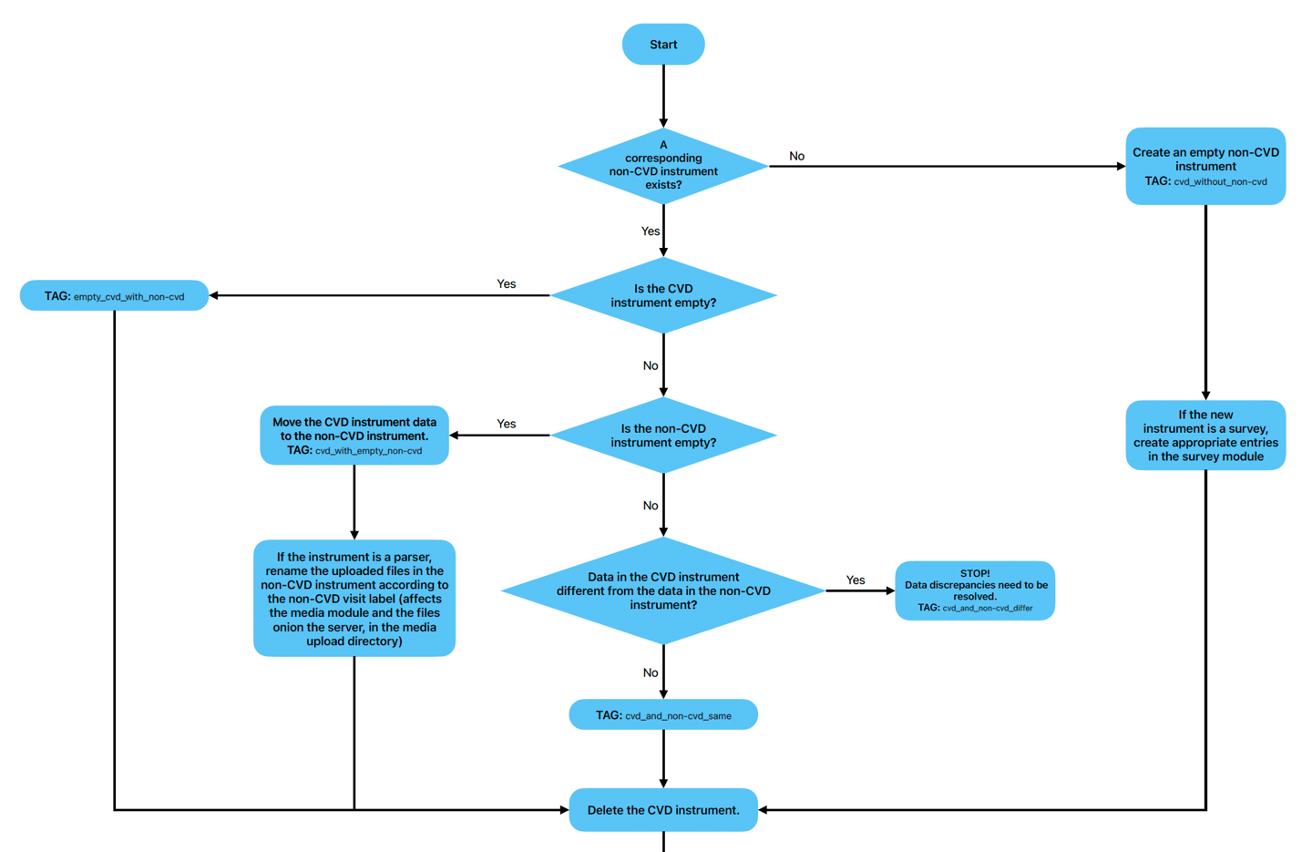
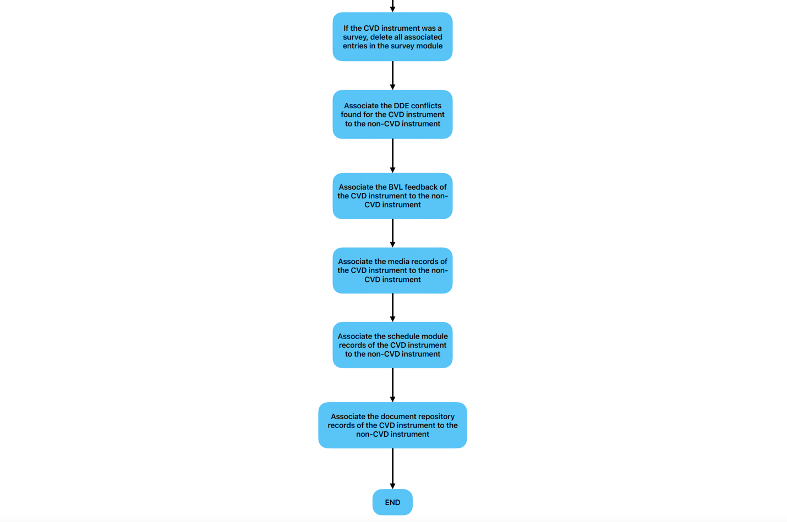

Figure 1. Flowchart of CVD Visit Merge logic for the instrument allocation pipeline

Instrument Labeling Scheme

The table below shows the action taken and the resulting instrument label outputs as defined by the preceding conditions:

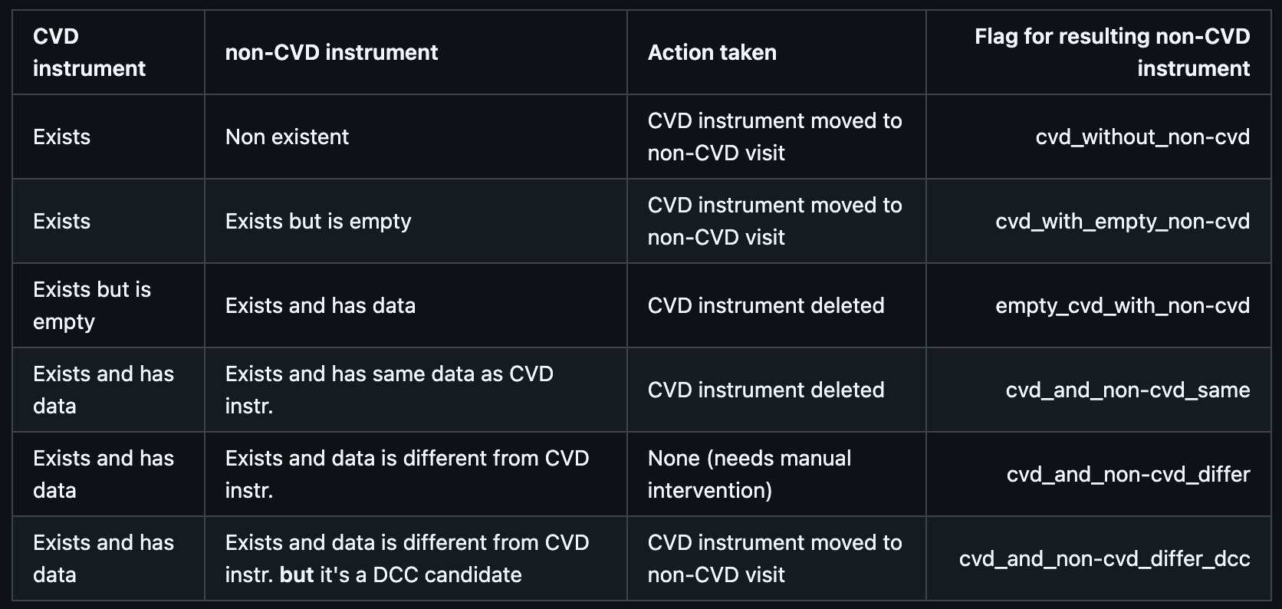

Table 1. Table delineating initial conditions, action taken and resulting flag label for instruments.

CVD Visit Merge - Audit

CVD Visits across studies:

TOTAL CVD Visits - ALL
Row Labels | Count of Identifiers
Down Syndrome Infant | 317
IBIS EP | 551
IBIS1 | 120
IBIS2 | 73
IDDRC-UNC | 29
Grand Total | 1090

CVD Visits- Visit Labels:

Row Labels | Count of Identifiers
V06-CVD | 330
V12-CVD | 268
V18-CVD | 60
V24-CVD | 154
V9-CVD | 85
VADOL-CVD | 38
VSA-CVD | 155
Grand Total | 1090

CVD Visits per visit:

TOTAL CVD Visits – ALL/Site
Row Labels | Down Syndrome Infant | IBIS EP | IBIS1 | IBIS2 | IDDRC-UNC | Grand Total
PHI | 85 | 117 | 13 | 15 |  | 230
SEA | 62 | 126 | 31 | 29 |  | 248
STL | 62 | 81 | 38 | 10 |  | 191
UMN |  | 106 |  |  |  | 106
UNC | 108 | 121 | 38 | 19 | 29 | 315
Grand Total | 317 | 551 | 120 | 73 | 29 | 1090

TOTAL CVD Visits - Infant Studies/Site
Row Labels | Down Syndrome Infant | IBIS EP | IDDRC-UNC | Grand Total
PHI | 85 | 117 |  | 202
SEA | 62 | 126 |  | 188
STL | 62 | 81 |  | 143
UMN |  | 106 |  | 106
UNC | 108 | 121 | 29 | 258
Grand Total | 317 | 551 | 29 | 897

TOTAL CVD Visits - SA/Site
Row Labels | IBIS1 | IBIS2 | Grand Total
PHI | 11 | 15 | 26
SEA | 26 | 29 | 55
STL | 26 | 10 | 36
UNC | 19 | 19 | 38
Grand Total | 82 | 73 | 155

TOTAL CVD Visit - ADOL/Site
Row Labels | IBIS1 | Grand Total
PHI | 2 | 2
SEA | 5 | 5
STL | 12 | 12
UNC | 19 | 19
Grand Total | 38 | 38

CVD Visits – Scan Done:

TOTAL CVD Visits - Scan Done
Row Labels | No | Yes | Grand Total
Down Syndrome Infant | 110 | 207 | 317
IBIS EP | 333 | 218 | 551
IBIS1 | 29 | 91 | 120
IBIS2 | 6 | 67 | 73
IDDRC-UNC | 10 | 19 | 29
Grand Total | 488 | 602 | 1090

CVD Visits – Current Stage:

TOTAL CVD Visits - Current Stage
Row Labels | Not Started | Visit | Grand Total
Down Syndrome Infant | 10 | 307 | 317
IBIS EP | 26 | 525 | 551
IBIS1 | 3 | 117 | 120
IBIS2 |  | 73 | 73
IDDRC-UNC |  | 29 | 29
Grand Total | 39 | 1051 | 1090

Testing Strategy

The testing strategy involved testing all possible CVD instruments, based on the following criteria:

- Whether the instrument belongs to a DCC candidate or not.
- The type of associated non-CVD instrument (non-existent, existent but empty, existent and with identical data, existent but with different data).
- The type of instrument (standard, single candidate parser, batch parser)
- Whether there is an associated issue or not.
  - For example, one of the instruments to consider might be a parser CVD instrument that belongs to a non-DCC candidate without a non-CVD instrument but with an associated issue and an associated session.

Testing procedure

- After the move, check the instrument is tagged with a ‘CVD’ flag.
- Review the flag corresponds to the correct label based on previous data entry and expected outcome for the flag.
- If the instrument is either a parser or a batch parser with an uploaded file, ensure the file has been renamed in the media module and can be downloaded.
- If the instrument has an issue, ensure the associated visit has been updated in the ticket.
- If a CVD session has been renamed into a non-CVD session, ensure that the session labels in the document repository have been updated accordingly.

Other Considerations

To complete the CVD Visit Merge process, all instruments need to be associated with their new non-CVD recipient visit. The allocation process is automated based on the logic presented above, but in some cases, if instruments at two visits for the same timepoints contain irreconcilable data, manual intervention is required to ascertain which instance of the instrument is the one that will be transferred to the final recipient visit for the timepoint.
Thus, until all conflicts are reconciled, or a decision is made for which instrument to keep in these cases, the full process will not be terminated, and the process to remove the CVD visit labels will be truncated, pending resolution of these cases.

Precautionary Measures

The following are some of the precautionary measures undertaken before/during the CVD merge:

1. Before the CVD merge script is run, a backup of all things directly tied to an instrument or a session, namely:
- Issue Tracker (issue_tracker)
- Participant Accounts (participant_account)
- Document Repository (document_repository)
- Conflicts Resolver (conflict_resolved; Resolved & Unresolved)
- Reliability Module (reliability)
- Behavioral Feedback (feedback_bvl_thread)

2. When the CVD merge script is run, before moving a CVD instrument to another visit or deleting a CVD instrument, the instrument record is backed up.
3. When the CVD merge script is run, before renaming or deleting a CVD visit, the visit record is backed up.

4. Procedure to be run end of day (7 pm EST), at which point the LORIS IBIS site will be disabled and will be unavailable. Site will be back online the next day. Please anticipate and adjust accordingly.

Conclusion

The implementation of the ‘CVD’ visit label was a crucial step in ensuring that IBIS research activities during the COVID-19 pandemic were appropriately documented, tracked, and analyzed. It not only preserved the integrity and relevance of the data collected during the pandemic, but also facilitated future reconciliation with non-pandemic data, ensuring that conclusions drawn from the research are scientifically robust and transparent.
The subsequent visit merge satisfies the need for a unified stream of timepoint to visit correspondence, critical for the upcoming analysis stages of the studies, while preserving the visit CVD distinction by shifting the ‘CVD’ information from the visit level to the instrument level in associated output flags based on the initial conditions.

