Title: Stability in EEG data quality and Bayley-4 cognitive scores across 6 and 12 month olds at higher likelihood of autism spectrum disorder
Authors: Madison Booth¹, Abigail Dickinson², Scott Huberty¹, Manjari Daniel², Alana Campbell³, Neely Miller⁴, Bonnie Lau⁵, John Zempel⁶, Sara Jane Webb⁷, Jed Elison⁴, Adrian K C Lee⁸ Annette Estes⁸, Stephen Dager⁹, Heather Hazlett³, Jason Wolff⁴, Robert Schultz¹⁰, Natasha Marrus⁶, Alan Evans¹¹, Joseph Piven³, John R Pruett Jr⁶, & Shafali Jeste¹ for the IBIS Network
Introduction: Autism spectrum disorder (ASD) is characterized by core social communication and behavioral deficits that emerge after the first year of life. The Infant Brain Imaging Study (IBIS) was established to examine structural and functional brain differences in infants at a higher likelihood of developing ASD (HL; denoted by the presence of an older diagnosed sibling). We recently published a manuscript detailing the addition of electroencephalography (EEG) to this MRI and behavioral based study (Dickinson et al., 2024). Protocol feasibility metrics demonstrated that 72.5% of all infants successfully completed the entire protocol at 6 and 12 months. Data quality remained high with 77.6% and 81.5% of resting state data retained after artifact removal across 6 and 12-month infants, respectively. In the following abstract, we investigated the relationship between cognitive abilities, as assessed by the Bayley Scales of Infant and Toddler Development (Bayley-4) and EEG data quality at 6 and 12 months of age.
Method: Developmental domains were measured through the Bayley-4 in 28 HL infants that had an EEG and Bayley-4 conducted at 6- and 12-month timepoints. Percentile rank on the cognitive domain of the Bayley-4 was extracted. A regression analysis was performed to investigate whether cognitive scores at 6-months of age predicted Bayley-4 cognitive scores at 12-months of age. Multivariate regression was also conducted to determine whether 6-month EEG data quality, measured by percentage of retainable seconds and EEG channels in cleaned resting state data, was predictive of retainable EEG time and channels at 12-months.
Results: Bayley-4 cognitive scores at 6-months of age were not predictive of Bayley-4 cognitive scores at the 12-month timepoint (Table 1). This was confirmed by calculating the Pearson Correlation Coefficient between these variables (r=0.08). Additionally, retainable EEG time and channel count post artifact removal at 12 months of age were not predicted by retainable EEG time and channel count at 6-months of age (Tables 2 &3).
 | β-coefficient | t-value | p-value
Intercept | 38.2 | 2.46 | 0.02
6m Cognitive Scores | 0.11 | 0.41 | 0.68
Table 1. Linear regression to determine whether cognitive scores at 6-months of age are predictive of 12-month cognitive scores. R²=0.007.

 | β-coefficient | t-value | p-value
Intercept | 57.6 | 2.44 | 0.02
Final 6m Time | -0.09 | -0.26 | 0.8
Final 6m Channels | 0.35 | 1.52 | 0.14

Table 3. Multivariate regression of retainable 6-month EEG, measured in time and channel count, in relation to 12-month retainable EEG time.

 | β-coefficient | t-value | p-value
Intercept | 87.7 | 9.66 | 0
Final 6m Time | -0.04 | -0.31 | 0.76
Final 6m Channels | 0.1 | 1.13 | 0.27
Table 2. Multivariate regression of retainable 6-month EEG, measured in time and channel count, in relation to 12-month retainable EEG time.

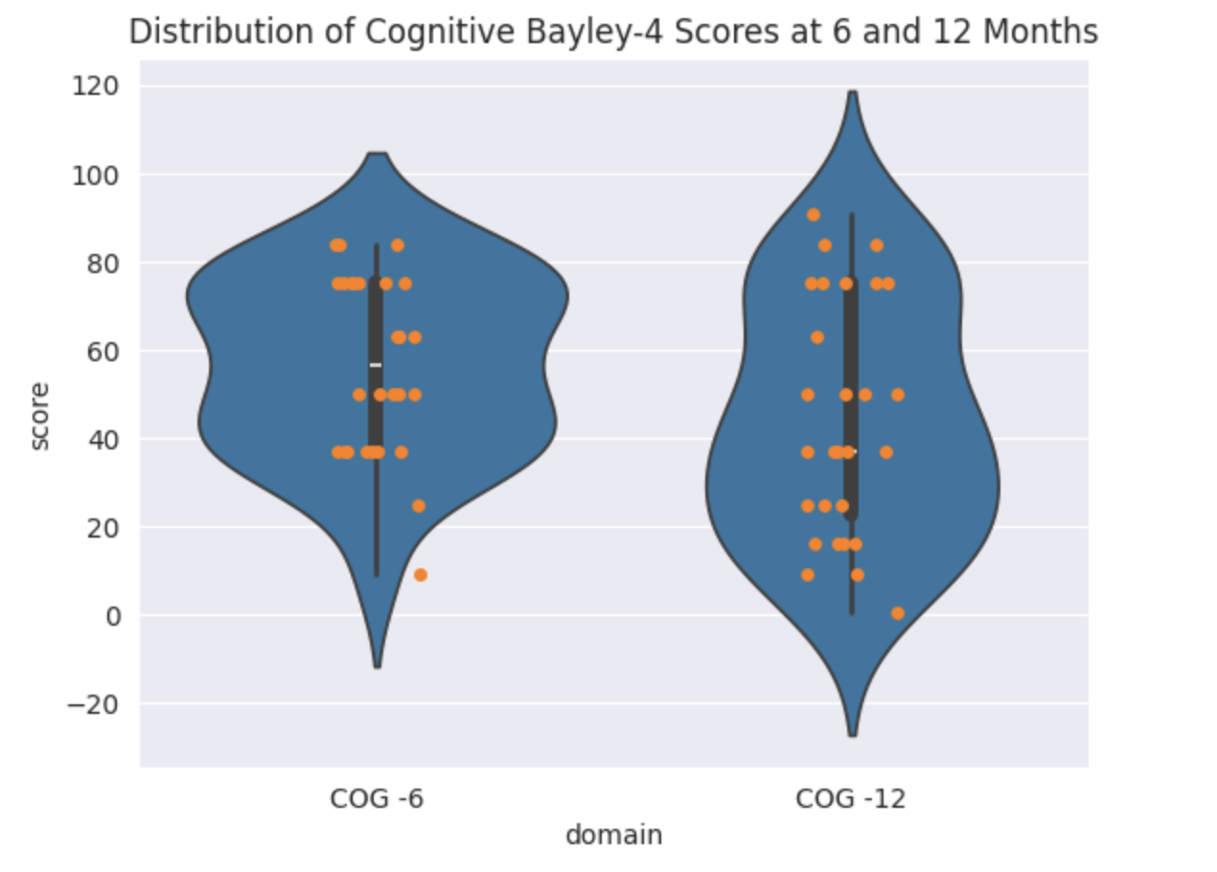
Figure 1. Distribution of Bayley-4 cognitive percentile scores across 28 infants with both 6 and 12-month timepoints.
Discussion: Regression and correlation analyses revealed no significant interaction between cognitive scores, as measured by the Bayley Scales of Infant and Toddler Development, at 6- and 12-months of age. This result is consistent with the currently published literature, indicating that early infancy developmental abilities are not a reliable metric of later development. These analyses also revealed that cognitive scores, as measured by the Bayley Scales of Infant and Toddler Development at 6- and 12-months did not predict EEG data quality at either timepoint. These findings suggest that data quality may remain independent of developmental level and support the continued use of EEG as a measure to examine infants that have developmental delays. It is possible that specific features of the EEG signal, such as spectral power or event related potentials will hold predictive value for infant development, and we plan to investigate how specific spectral characteristics map onto cognitive scores for these infants across time.
References:
Dickinson A, Booth M, Daniel M, Campbell A, Miller N, Lau B, Zempel J, Webb SJ, Elison J, Lee AKC, Estes A, Dager S, Hazlett H, Wolff J, Schultz R, Marrus N, Evans A, Piven J, Pruett JR Jr, Jeste S; IBIS Network. Multi-site EEG studies in early infancy: Methods to enhance data quality. Dev Cogn Neurosci. 2024 Oct;69:101425. doi: 10.1016/j.dcn.2024.101425. Epub 2024 Jul 31. PMID: 39163782; PMCID: PMC11380169.
Liu TY, Chang JH, Peng CC, Hsu CH, Jim WT, Lin JY, Chen CH, Li ST, Chang HY. Predictive Validity of the Bayley-III Cognitive Scores at 6 Months for Cognitive Outcomes at 24 Months in Very-Low-Birth-Weight Infants. Front Pediatr. 2021 May 7;9:638449. doi: 10.3389/fped.2021.638449. PMID: 34026684; PMCID: PMC8138438.
Hazlett HC, Gu H, Munsell BC, Kim SH, Styner M, Wolff JJ, Elison JT, Swanson MR, Zhu H, Botteron KN, Collins DL, Constantino JN, Dager SR, Estes AM, Evans AC, Fonov VS, Gerig G, Kostopoulos P, McKinstry RC, Pandey J, Paterson S, Pruett JR, Schultz RT, Shaw DW, Zwaigenbaum L, Piven J; IBIS Network; Clinical Sites; Data Coordinating Center; Image Processing Core; Statistical Analysis. Early brain development in infants at high risk for autism spectrum disorder. Nature. 2017 Feb 15;542(7641):348-351. doi: 10.1038/nature21369. PMID: 28202961; PMCID: PMC5336143.
Department of Neurology, Children’s Hospital of Los Angeles, Los Angeles, CA, USA
2 Center for Autism Research and Treatment, Semel Institute for Neuroscience, University of California, Los Angeles, CA, USA
3 Carolina Institute for Developmental Disabilities, Department of Psychiatry, University of North Carolina at Chapel Hill, Chapel Hill, NC, USA
⁴ Center for Neurobehavioral Development, Department of Pediatrics, University of Minnesota, Minneapolis, MN, USA
⁵ Department of Otolaryngology – Head and Neck Surgery, University of Washington, Seattle, WA, USA
⁶ Department of Psychiatry, Washington University School of Medicine, St. Louis, MO, USA
⁷ Center for Child Health, Behavior, and Development, Seattle Children’s Research Institute, Seattle, WA, USA
⁸ Department of Speech and Hearing Sciences, Institute for Learning and Brain Sciences, University of Washington, Seattle, WA, USA
⁹ Department of Radiology, University of Washington, Seattle, WA, USA
¹⁰ Center for Autism Research, Children’s Hospital of Philadelphia, University of Pennsylvania Perelman School of Medicine, Philadelphia, PA, USA
¹¹ McGill Centre for Integrative Neuroscience, Montreal Neurological Institute, McGill University, Montréal, QC, Canada

