**Title:** Effects of sleep on motor abilities of infants with higher vs. lower familial likelihood of autism in the first year of life

**Authors:** Mallory Leff, Jeff Munson, Stephen R. Dager, Tanya St. John, Joseph Piven, Heather Hazlett, Robert Schultz, Natasha Marrus, Lonnie Zwaigenbaum, Juhi Pandey, Mark Shen, and Annette Estes, for the IBIS Network

**Background:** Sleep alterations can become evident in infants who later develop autism spectrum disorder (ASD) as early as 6 to 12 months of age1,2. Infants with a higher familial likelihood of developing ASD (HL) demonstrate longer sleep onset latency and increased nighttime awakenings1,2. HL infants who are diagnosed with ASD also tend to show less advanced gross motor skills compared to typically developing infants between 6 and 24 months3. Research indicates that daytime sleep (naps) influences motor learning in typically developing infants4. Motor *abilities* represent an accrual of previous learning experiences and maturation, in contrast to motor *learning*. The impact of sleep alterations on motor abilities in HL infants is not well understood. Given the role of sleep in motor learning in the first year of life, understanding how sleep relates to motor abilities has the potential to identify mechanisms in the early development of autism and guide the timing and implementation of effective interventions.

**Objective:** We aim to examine the relationships between sleep and motor abilities in infants with higher familial likelihood and lower familial likelihood of developing ASD.

**Method:** Participants were part of the ongoing, multi-site Infant Brain Imaging Study (IBIS) and Sleep Study. Sleep alterations in 192 infants (HL 144; LL 48) at 6 months, 134 (HL 107; LL 27) at 12 months, and 104 (HL 81; LL 23) longitudinally at 6 and 12 months were evaluated using the Brief Infant Sleep Questionnaire. Motor abilities were assessed using two examiner-delivered, standardized measures: the Bayley Scales of Infant and Toddler Development (Bayley; Gross Motor, Fine Motor), and Alberta Infant Motor Scale (AIMS; Total Score). Multiple regression analysis was used to assess if sleep is associated with motor abilities and whether this association differs between groups.

**Results:** At 6 months, there was an association between daytime sleep and standardized motor ability scores in LL (AIMS r=0.39; p=.033; Bayley Gross Motor r=0.37; p=.008) but not HL infants (AIMS r= -0.03; ns; Bayley Gross Motor r= -0.02; ns). The AIMS Total Score was related to sleep at 6 months but the group by Daytime Sleep interaction term fell short of significance (see Table 1). We found no significant relationships between sleep and motor abilities at 12 months or longitudinally from 6 to 12 months.

**Discussion**: We found partial, preliminary support for an association between daytime sleep and motor ability consistent with a previously established relationship between naps and motor learning in typically developing infants in the first year of life. As this is an ongoing longitudinal study, future research will include outcome diagnosis at 24 months of age which may shed further light on group differences. The sample size will continue to increase and, if these relationships hold, the trend-level group by Daytime sleep associations observed here will be clarified. Future research is needed to provide insights into the influence of sleep on the developmental trajectories of infants.

**References**

1. MacDuffie, K. E., Shen, M. D., Dager, S. R., Styner, M. A., Kim, S. H., Paterson, S., … Estes, A. M. (2020). Sleep Onset Problems and Subcortical Development in Infants Later Diagnosed With Autism Spectrum Disorder. *American Journal of Psychiatry*, *177*(6), 518–525.
2. Begum-Ali J, Gossé LK, Mason L, Pasco G, Charman T, Johnson MH, Jones EJH; STAARS Team. Infant sleep predicts trajectories of social attention and later autism traits. J Child Psychol Psychiatry. 2023 Aug;64(8):1200-1211. doi: 10.1111/jcpp.13791. Epub 2023 Mar 29. PMID: 36991307; PMCID: PMC10952761.
3. Estes, A., Zwaigenbaum, L., Gu, H. *et al.* Behavioral, cognitive, and adaptive development in infants with autism spectrum disorder in the first 2 years of life. *J Neurodevelop Disord* **7**, 24 (2015). <https://doi.org/10.1186/s11689-015-9117-6>
4. Horger, M. N., DeMasi, A., Allia, A. M., Scher, A., & Berger, S. E. (2023). The unique contributions of day and night sleep to infant motor problem solving. *Journal of Experimental Child Psychology*, *226*, 105536. https://doi.org/10.1016/j.jecp.2022.105536

**Figure 1.** The association between daytime sleep and motor abilities in HL and LL infants at 6 months of age

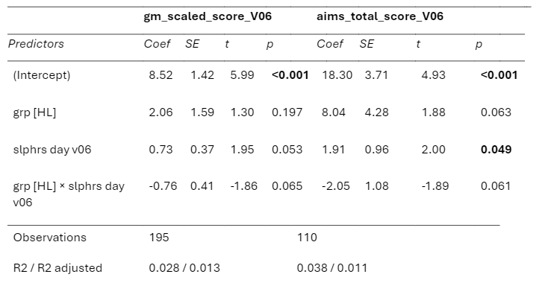**Table 1.** The association of daytime sleep and motor abilities in HL and LL infants at 6 months of age