Cognitive and motor skills predict EEG data quality in infants at high likelihood for Autism Diagnosis.

Authors: Madison Booth, Abigail Dickinson, Scott Huberty, Manjari Daniel, Alana Campbell, Neely Miller, Bonnie Lau, John Zempel, Sara Jane Webb, Jed Elison, Adrian K C Lee, Annette Estes, Stephen Dager, Heather Hazlett, Jason Wolff, Robert Schultz, Natasha Marrus, Alan Evans, Joseph Piven, John R Pruett Jr, & Shafali Jeste for the IBIS Network

Background: Autism spectrum disorder (ASD) is characterized by core social communication and behavioral deficits that emerge after the first year of life. The Infant Brain Imaging Study (IBIS) was established to examine structural and functional brain differences in the first year of life in infants at a higher likelihood of developing ASD (HL; denoted by the presence of an older diagnosed sibling). We recently published a manuscript detailing the addition of electroencephalography (EEG) to this MRI and behavioral based study (Dickinson et al., 2024). Protocol feasibility metrics demonstrated that 72.5% of all infants successfully completed the entire protocol at 6 and 12 months. Data quality remained high with 77.6% and 81.5% of resting state data retained after artifact removal across 6 and 12-month infants, respectively.

Objectives: After establishing and testing a standardized protocol to acquire EEG data from HL infants, we asked whether developmental abilities, assessed by the Bayley Scales of Infant and Toddler Development (Bayley-4) at age 6-months, predicted EEG data quality in these infants. The cognitive and motor domains of the Bayley were assessed in relation to clean resting state EEG data. We hypothesized that at 6 months of age, motor abilities would show a stronger association to higher EEG quality compared to cognitive scores.

Methods: Developmental domains were measured through the Bayley-4 in 60 6-month-old infants at HL for ASD. Percentile rank on the cognitive and motor domains were extracted. Correlations between the percentage of clean EEG time and both the cognitive and motor domains was conducted. A multivariate regression was performed to investigate whether cognitive and motor scores predicted total seconds of clean EEG time and total number of clean EEG channels after artifact removal.

Results: The Bayley-4 cognitive score was more highly correlated with percent of clean EEG data with r= 0.10 compared to the motor subscale (r= -0.012). Multivariate regression showed that neither cognitive or motor scores were a statistically significant predictors of clean EEG data, measured in time and channel count (Tables 1 & 2).

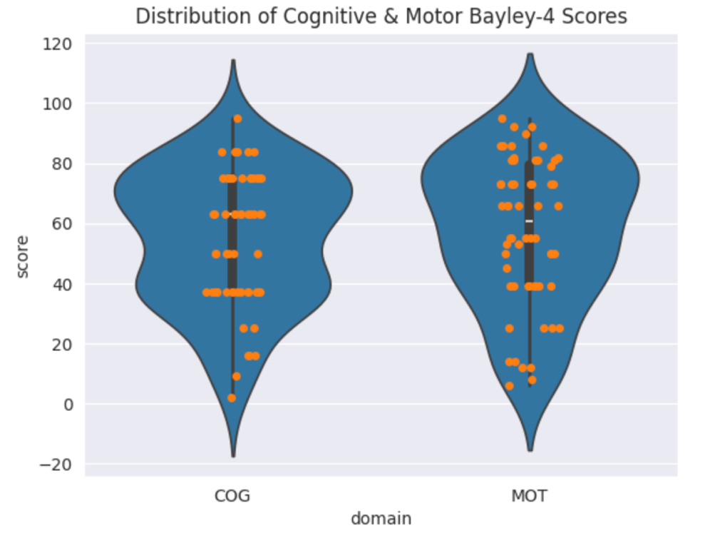

Figure 1. Percent distribution of cognitive and motor scores on the Bayley-4 of all 60 infants included in analysis.

Clean EEG Time as a Function of Cognitive and Motor Bayley-4 Scores
R²=0.016
 | β-coefficient | t-value | p-value
Intercept | 89.6 | 36.4 | 0.0
Cognitive Score | 0.04 | 0.95 | 0.34
Motor Score | -0.02 | -0.56 | 0.58

Table 1. Multivariate regression results across the amount of clean EEG data, measured in time.

Retained EEG Channels as a Function of Cognitive and Motor Bayley-4 Scores
R²= 0.038
 | β-coefficient | t-value | p-value
Intercept | 68.8 | 16.5 | 0.0
Cognitive Score | 0.11 | 1.48 | 0.14
Motor Score | -0.06 | -0.93 | 0.36

Table 2. Multivariate regression results across the percent of retained EEG channels after artifact removal.

Conclusions: The analyses revealed that neither the cognitive nor motor scores, as measured by the Bayley Scales of Infant and Toddler Development at 6-months of age predicted data quality. These findings suggest that data quality may remain independent of developmental level and support the continued use of EEG as a measure to examine infants that may have developmental delays. It is possible that specific features of the EEG signal, such as spectral power or event related potentials will hold predictive value for infant development. In addition to confirming the above results at 12-month timepoints, we plan to investigate how specific spectral characteristics map onto cognitive and motor scores for these infants.

