**Optimizing EEG Integration in a Multi-site Infant Study: Early Evaluations and Key Insights**

Abigail Dickinson Center for Autism Research and Treatment, Semel Institute for Neuroscience, University of California.

Madison Booth Department of Neurology, Children’s Hospital of Los Angeles

Manjari Daniel

Alana Campbell

Neely Miller

Bonnie Lau

John Zempel

Sara Jane Webb

Jed Elison

Adrian KC Lee

Annette Estes Department of Speech and Hearing Sciences, University of Washington, Seattle

Stephen Dager

Heather Hazlett

Jason Wolff

Robert Schultz

Natasha Marrus

Alan Evans

Joe Piven

John R. Pruett, Jr.

& Shafali Jeste  Department of Neurology, Children’s Hospital of Los Angeles

for the IBIS Network

Correspondence should be addressed to:

Abigail Dickinson at Center for Autism Research and Treatment, Semel Institute for Neuroscience, University of California, 760 Westwood Plaza, Suite A7-469, Los Angeles, CA 90095, USA.

adickinson@mednet.ucla.edu

**Keywords*:***

**Author contributions**

All authors made substantial contributions to the conception of the work (); acquisition, analysis and interpretation of data () and drafted or revised the manuscript (all authors).

**Conflict of Interest:**

The authors (AD, MB… ) declare that the research was conducted in the absence of any commercial or financial relationships that could be construed as a potential conflict of interest.

**IBIS Network Boilerplate**

The Infant Brain Imaging Study (IBIS) is a collaborative effort of the Lead PI, four clinical sites, a Data Coordinating Center, a Behavioral Core, an Imaging Core a Statistics Core, Genetics Core and Environmental Risk Core. It is funded by the United States National Institute of Health.

**The Infant Brain Imaging Study-Early Prediction project (IBIS-EP)** is an U.S. National Institute of Mental Health-funded study and consists of a consortium of 10 universities in the U.S.A. and Canada. The study includes infants at high familial risk for autism spectrum disorder (ASD), based on having an older sibling with the diagnosis. Infants are seen at ages 6, 12, and 24 months for brain MRI scans and behavioral tests. Members and components of IBIS-EP include: **Co-PIs:** J.R. Pruett, Jr. & J. Piven; **Clinical Sites:** Children’s Hospital of Philadelphia (CHOP): R.T. Schultz, J. Pandey, J. Parish-Morris, B. Tunç, W. Guthrie; University of Minnesota (UMN): J.T. Elison, J.J. Wolff; University of North Carolina (UNC): J. Piven, H.C. Hazlett, M.D. Shen, J.B. Girault, R. Grzadzinski; University of Washington (UW): S.R. Dager, A.M. Estes, T. St. John, D. Shaw; Washington University School of Medicine in St. Louis (WU): K.N. Botteron, R.C. McKinstry, J.N. Constantino, N. Marrus; **Admin Core:** WU: Alicia Rocca; UNC: J.C. Chappell; **Behavior Core:** UW: A.M. Estes, T. St. John; University of Alberta: L. Zwaigenbaum; UMN: J.T. Elison, J.J. Wolff; University of Texas at Dallas: M.R. Swanson; **MRI Core:** UNC: M.A. Styner, M.D. Shen; New York University: G. Gerig; WU: J.R. Pruett, Jr., R.C. McKinstry; UMN: J.T. Elison; UW: S.R. Dager; **Data Coordinating Center:** Montreal Neurological Institute: A.C. Evans, L.C. MacIntyre, S. Torres-Gomez, S. Das; **Statistical Analysis Core:** UNC: K. Truong; **Scientific Rigor and Responsibility Core:** J. Girault, UNC, M. Swanson, UTDallas; **Environmental Risk Core**: John Hopkins University (JHU): H. Volk; **Genetics Core:** JHU: M.D. Fallin; UNC: M.D. Shen; J. Girault; **EEG:** University of California, Los Angeles: S.S. Jeste; **Ethical, Legal, and Social Implications Core:** UW: K.E. MacDuffie.

**Acknowledgement:**

Support for the Infant Brain Imaging Study (IBIS) provided by NIMH X & NIMH X. No company contributed to funding of this study. Additional important contributions were provided by members of the IBIS network including: please add any staff who should receive acknowledgement.

**Data Availability**

Data for the present study will be accessible via NIMH NDA (#).

**Ethical statement**

The research was conducted in accordance with the principles embodied in the Declaration of Helsinki and in accordance with local statutory requirements. Human subjects’ oversight was provided by the Washington University in St. Louis institutional review board and human protection office.

**Abstract:** EEG and MRI studies have identified early brain differences linked to autism spectrum disorder (ASD), which manifest before overt behavioral symptoms. These neural precursors offer insights into the developmental pathways leading to ASD and have the potential to inform markers for early identification. However, effectively utilizing structural and functional brain differences as neural indicators requires more comprehensive investigation through multi-modal studies with larger and more diverse cohorts. In this context, we integrated EEG into an existing multi-site MRI study of infants with higher likelihood of developing ASD. This paper describes the comprehensive protocol established to collect longitudinal high-density EEG data recordings from infants across five research sites and shares interim feasibility and data quality results. We assessed feasibility by determining the percentage of infants we successfully collected EEG from, and data quality based on the duration of EEG remaining after artifact removal. Preliminary analyses show a 96% success rate in EEG data collection, with an average of 480 seconds of clean, task-free data retained across sites (89% of total recording time). Feasibility and data quality metrics were highly consistent across sites regardless of experience level, reinforcing the adaptability and scalability of our protocol. The insights gained from this preliminary analysis serve as a valuable guide for our ongoing data collection and may offer a useful resource for similar research endeavors.

**Data Summary:** EEG and MRI findings of infant brain differences offer promise for earlier detection of autism spectrum disorder (ASD) and advancing our understanding of the underlying neural pathways. However, translating neural findings into clinical markers requires investigation in large samples using multi-site, and multimodal imaging approaches. Here we describe a comprehensive approach to integrating infant EEG recording into an established MRI study of infants with high familial likelihood of ASD, due to a full older sibling with an ASD diagnosis. We also present preliminary metrics describing feasibility and quality of data collected so far.

**Lay Summary:** EEG and MRI studies have identified early brain differences that can be detected before the behavioral symptoms of autism spectrum disorder (ASD) become apparent. These neural markers could provide insights into ASD's developmental pathways and potentially aid early detection. To better understand early neural indicators, we integrated EEG into an extensive, multisite MRI study targeting infants at higher likelihood of ASD, due to a full older diagnosed sibling. This paper describes the framework we developed to navigate the inherent challenges of collecting infant EEG across sites with varying expertise. Our preliminary results reveal consistent EEG data collection across all locations, regardless of their prior EEG familiarity. This achievement underscores the potential of combined modalities in advancing our understanding of ASD's early neural precursors, setting a precedent for future collaborative research.

**Data highlights**

- Early brain differences linked to autism spectrum disorder (ASD) have been identified through EEG and MRI studies, which have the potential to inform markers for earlier ASD identification

- Multi-modal studies with larger and more diverse cohorts are needed to effectively utilize these structural and functional brain differences as neural indicators

- An EEG protocol was integrated into an existing multi-site MRI study of infants with higher familial likelihood of developing ASD

- Preliminary analyses show a 96% success rate in EEG data collection, with an average of 480 seconds of clean, task-free data retained across sites (89% of total recording time)

- Feasibility and data quality metrics were highly consistent across sites, reinforcing the adaptability and scalability of the protocol

1. **Introduction**

Autism spectrum disorder (ASD) is a complex neurodevelopmental condition characterized by social and behavioral impairments that typically emerge after the first year of life (APA, 2013; Pierce et al. 2009; Zwaigenbaum & Penner, 2018). Accumulating evidence suggests that neural differences underlying ASD originate during early brain development, well before behavioral symptoms (Girault & Piven, 2020). Early detection of these neural indicators could aid in the pre-symptomatic identification of at-risk infants (McPartland et al., 2020; Jeste et al., 2015), providing a clearer understanding of ASD's early neurobiological pathways (Modi & Sahin, 2017; Jeste and Nelson., 2009), and paving the way for timely interventions that leverage the brain's heightened plasticity early in life.

Using techniques such as MRI and EEG in the first year of life, researchers have identified specific structural and functional brain differences associated with ASD. (EEG: Orekhova et al., 2014; Righi et al., 2014; Gabard-Duram et al., 2019; Haartsen et al., 2019; Peck et al., 2021; Dickinson et al., 2021; Jones et al., 2016; MRI: Wolff et al., 2012; Shen et al., 2013; Shen et al., 2017; Hazlett et al., 2017; Emerson et al., 2017). These pre-symptomatic investigations primarily focus on infants with older siblings diagnosed with ASD, who have a higher likelihood (HL) of developing ASD (~20%) (Ozonoff et al., 2011) compared to the general population (~2%) (Maenner et al., 2021). Given that only a portion of HL infants go on to develop ASD, collaborative multisite studies are vital, helping to mitigate recruitment constraints and the risk of findings limited by small sample sizes.

By pooling resources, expertise, and participants across various geographical locations, multisite studies can ultimately enhance the robustness and generalizability of identified neural markers, increasing their clinical utility. One such initiative is the Infant Brain Imaging Study (IBIS) Network. Spanning five US research institutions, IBIS combines behavioral assessments and Magnetic Resonance Imaging (MRI) at 6, 12, and 24 months in HL infants to examine brain and behavioral trends linked to subsequent ASD diagnosis at 24 months. Insights from the initial IBIS cohort have revealed structural and functional brain differences preceding an ASD diagnosis or associated behavioral symptoms. For instance, cortical surface overgrowth between 6 and 12 months of age (Hazlett et al., 2017), and excessive volumes of extra-axial CSF at six months ((Shen et al., 2013), (Shen et al., 2017), (Shen et al., 2018)) in the initial IBIS cohort were linked to ASD diagnosis at age 2. In the same sample, accelerated amygdala overgrowth between 6 and 12 months predicted increased social deficits (but not repetitive behaviors) by 24 months (Shen et al., 2022).

Furthermore, insights from IBIS implicate changes in network function as a robust early marker of ASD. These include differences in functional connectivity at 6 months (Emerson et al., 2017) and alterations in structural white matter development between 6 and 24 months (Wolff et al., 2012, 2015, 2017), which were both related to ASD outcomes. These functional disruptions are consistent with electrophysiological evidence of early atypical network function related to ASD outcomes (Gabard-Durnam et al., 2019; Dickinson et al., 2021). However, it is still unclear how EEG and MRI findings relate to each other, or whether they refect mechanistic differences during this pre-symptomatic period.

Integrating EEG and MRI through large multisite investigations presents a valuable opportunity to better understand the early neural variations preceding ASD diagnosis. Such multimodal approaches capitalize on the strengths of both techniques offer a complementary perspective on brain development. While MRI provides intricate structural images and information about brain function using blood flow as a proxy for brain activity, EEG directly measures the electrical activity of neuronal ensembles, capturing rapid and dynamic temporal shifts in neural patterns. As such, EEG allows us to examine functional patterns and neural correlates of basic sensory processing while infants are awake, offering insights that complement those obtained from infant MRI, typically conducted during sleep. For instance, EEG may be particularly useful in capturing measures of active visual processing that can complement recent MRI findings implicating visual system differences in ASD (Girault et al., 2022). EEG is also cost-effective and adaptable to various environments, making it highly suitable for extensive longitudinal studies and the development of scalable ASD screening markers.

Incorporating EEG alongside MRI into the latest IBIS data collection protocol offers a unique opportunity to gain a more comprehensive understanding of early brain differences in ASD. However, the practical implementation of this integrated approach presents several unique challenges. Rigorous protocols and strict standardization are crucial for consistent and reliable EEG data collection in multisite studies (McPartland et al., 2020, Webb et al., 2023). At the same time, working with infant populations necessitates the flexibility to accommodate dynamic and unpredictable behavior patterns. Infants are often more sensitive to unfamiliar lab settings, may have difficulty completing EEG data collection sessions, and exhibit frequent physiological or movement artifacts that can undermine the useability of collected data (Herve et al., 2022, Van Diessen et al., 2015). Incomplete sessions, shorter recording durations, and artifacts mean that infant EEG studies frequently observe data loss rates as high as 50% (Cuevas et al., 2014; Stets et al., 2012), limiting research insights to those who provide adequate data. Furthermore, given that the IBIS initiative was originally established based on MRI expertise, teams varied significantly in their EEG collection experience. This variability posed a risk of increasing the data loss inherent in multi-site and longitudinal research. Recognizing both the value and challenge of a multisite collaboration, we developed a comprehensive strategy to add EEG data collection to the IBIS protocol. This approach balanced the diverse needs of each site with preserving and enhancing data fidelity.

To design this standardized protocol, we combined our team's in-house expertise with existing guidance from the literature, particularly focusing on gold-standard procedures for infant EEG acquisition (Webb et al., 2015, Van der Velde & Jung, 2020, Herve et al., 2022, Cuevas et al., 2014) and best practices for multi-site data collection (Abraham et al., 2017, Webb et al., 2020, Jones et al., 2009, Volkow et al., 2021). This paper outlines our comprehensive protocol designed for the collection, harmonization, and quality control of multi-site infant EEG data within the IBIS network (see Figure 1). We also report a preliminary evaluation of EEG data quality using this approach. Our assessments offer insight into the protocol's feasibility, evaluated using completion rates, and data quality, quantified by the duration of task-free data retained after artifact removal.

1. **Methods**

***Participants***

Participants in the present study were enrolled in IBIS, an ongoing prospective cohort study across five sites: Washington University in St. Louis, University of Washington in Seattle, Children's Hospital of Philadelphia, University of Minnesota, and the University of North Carolina at Chapel Hill. To qualify for the IBIS study, infants were required to have a full older sibling diagnosed with ASD. Sibling diagnoses were validated using medical records, the Social Communication Questionnaire (SCQ) (Rutter, Bailey, et al., 2003), and the Autism Diagnostic Interview-Revised (ADI-R) (Rutter, LeCouteur, et al., 2003). Additional eligibility criteria included: 1) Gestational age > 36 weeks; 2) Absence of medical or neurological conditions influencing growth, development, or cognition (e.g., seizure disorders) or significant sensory impairments (like vision or hearing loss); 3) No known genetic syndromes associated with ASD;  4) No immediate family history of psychosis, schizophrenia, or bipolar disorder (Family Interview for Genetic Studies; Maxwell, 1992); 5) No MRI contraindications, and 6) English as primary home language. These criteria, ascertained during a Family History Interview, align with those used in previous IBIS studies (Emerson et al., 2017; Hazlett et al., 2017).

The target recruitment for IBIS is 250 infants, with 50 infants at each of the five participating sites. The protocol includes EEG and MRI recordings (non- simultaneous) at 6 and 12 months of age and behavioral testing at 6, 12, and 24 months (See Figure 2A). Infants were enrolled at 6 months of age. EEGs at 6 and 12 months were scheduled within a testing window of -1 week/ +3 weeks from the preferred date based on the infant's birth date (for details on enrollment beyond 6 months, see Supplementary Information). Prior to data collection, all study protocols were reviewed and approved by a centralized IRB at Washington University in St. Louis. A parent or guardian provided written informed consent for each participating infant, in compliance with the Declaration of Helsinki. The data described in this paper represent all 6 (n = 73) and 12-month (n = 47) EEG recordings conducted prior to January 1st, 2023. Demographic information for this preliminary sample is described in Table 1.

A dedicated team, independent from the five data collection sites, coordinated EEG efforts, including training, troubleshooting, and data quality reviews. Clinical outcomes and EEG metrics pertinent to our research objectives are outside the scope of this paper since data collection is still in progress. However, we present feasibility and quality metrics related to our initial efforts in EEG data collection.

***EEG Paradigms***

The IBIS study collected EEG data during three distinct paradigms, organized into five testing blocks (Figure 2B). We selected these paradigms based on their suitability for infant populations and their capacity to provide insights into different aspects of brain function, including basic resting-state functional architecture and low-level sensory processing. The selected paradigms also aligned with established IBIS goals, allowing for a comprehensive, multi-modal assessment and the opportunity for subsequent integrated analyses. This paper details collection rates for each paradigm to evaluate the feasibility of our protocol and provides in-depth metrics to characterize the quality of data collected in one specific paradigm – task-free spontaneous EEG.

*Task-free:* To capture spontaneous brain activity, we recorded continuous EEG data under task-free conditions for a total of 9 minutes, divided into three 3-minute blocks. Floating bubbles were presented on a laptop screen, in line with the procedures used to obtain task-free recordings from infant populations (Levin et al., 2019).

*Visual Evoked Potentials (VEP):* A conventional VEP paradigm displayed a black-and-white square checkerboard pattern on the IBIS laptop screen, set against a mean luminance background with a small red fixation cross in the center. The contrast of the checkerboard reversed every 500 ms for 160 trials.

*Auditory Evoked Potentials (AEP):* A sound bar (ELEGIANT SR200) presented a pure tone, calibrated to 80 dB SPL. The auditory stimulus was a 500 Hz pure tone with a duration of 300 ms, including a 10 ms onset and offset ramp. The tone was presented 140 times, with a randomized inter-stimulus interval varying between 800 to 1200 ms. To keep infants engaged, a video of floating bubbles (identical to that used in the task-free paradigm), was displayed on the screen during the presentation of the auditory stimuli. This paradigm lasted approximately 3.5 minutes, on average.

# *Standardized EEG Acquisition Setup*

## *Core EEG Components and Site-Specific Variations***:** EEG acquisition relies on multiple components functioning together, with millisecond precision communication. Briefly, electrodes on the participant's scalp capture brain-generated electrical activity, which is then transmitted to an amplifier. The amplifier is connected to a data-acquisition computer (DAC), recording the amplified signals and enabling real-time data review by the experimenter. Additionally, the DAC links to an experiment control computer (ECC), which generates and presents stimuli to the participant. The ECC typically uses two screens: one for the experimenter to control stimuli and another external monitor facing the participant for stimulus display. In addition to coordinating stimulus timing, the ECC transmits information documenting the exact timing of stimulus presentation to the DAC, which is recorded as ECI events in Net Station.

Despite these standard components, equipment and setup can vary significantly across EEG labs due to unique study requirements and shared equipment use. Such variations can affect data consistency and quality, and impede data processing and troubleshooting, particularly in remote multi-site studies. As such, standardizing equipment is key for ensuring consistent data and ongoing success across sites, reducing technical disruptions and variations over time.

Given that implementing new identical systems across sites was impossible due to budgetary constraints, our study adopted a streamlined approach to standardize equipment. We began by identifying core EEG components common to all sites. This involved a detailed evaluation of existing hardware, acquisition methods, and recording practices at each location. Our goal was to ensure uniform data collection while minimizing disruptions. A key aspect of this standardization was replacing the traditional ECC with an IBIS-specific laptop, as described below. By focusing on essential EEG components and implementing consistent equipment, we effectively reduced potential variations, ensuring a more uniform and efficient data collection across all sites.

## *Streamlining EEG Equipment:*Due to budgetary considerations, we optimized the use of existing EEG equipment at each site. Although some equipment varied, all sites had consistent foundational components, such as the EGI NetAmps amplifier and associated Hydrocel Geodesic Sensor Nets (see Figure 3A for relevant site-specific differences). To enhance consistency, we provided identical IBIS-specific laptops to each site which dual-functioned as an ECC and a participant display monitor (see Figure 3B). This reduced setup intricacies and potential interference points with other equipment. For data collection, the sole modification needed was connecting the DAC to the standardized laptop. This approach was aimed at ensuring the integrity and quality of EEG data collection, helping to minimize issues with data collection for IBIS while minimally disrupting other ongoing studies at each site. Despite DAC variations across sites, stringent control over recording parameters was achieved using EGI NetStation software with a standardized acquisition template. This streamlined setup enabled researchers to prioritize participant comfort, enhancing data quality. Consistent peripheral hardware was also used across sites, including devices for stimulus presentation (ELEGIANT SR200 Soundbar), controlling and timing stimuli (wireless keyboard; AV device), and video recording (Cimkiz A860 USB 2.0 HD Webcam), as described below.

*Synchronizing Stimulus-Specific Timing:* Ensuring timing synchronization during Event-Related Potential (ERP) procedures was a key consideration in our study. Given that AEP and VEP paradigms are designed to capture stimulus-elicited responses on a millisecond level, accurately aligning timing markers with the causal stimuli is vital for identifying specific time-domain components, averaging data, and understanding sensory processes. Although the ECC transmits stimulus presentation markers to the DAC, hardware communication latencies can compromise the accuracy of these markers in EEG recordings. We addressed this using the Audio/Visual (AV) Device provided with the EGI system. Typically used for timing checks, we adapted the AV device to act as a stimulus monitor, capturing the precise timing stimuli were presented to participants. Specifically, by directly recording sound output from the laptop (AEP) and detecting luminance changes using a photodiode sensor affixed to the laptop screen (VEP), the AV device ensured the precise stimulus-EEG data alignment that is critical for ERP analysis.

***Standardized Training and Data Collection Protocols***

After implementing standardized equipment, we prioritized the development of universal training protocols to cater to all team members, accounting for diverse experience levels with EEG and/or infant populations.

*In-Person Setup & Training:* The core EEG team visited each data collection site to implement the equipment configurations formulated in Phase 1 and provide hands-on training. Where needed, this covered an EEG introduction, nuances of infant EEG data collection, and guidelines for interacting with participants/families and ensuring their comfort.

*Standardized Protocols, Data Recording & Stimulus Presentation:*A comprehensive Manual of Procedures (MOP) was developed and maintained to detail standardized protocols for EEG data acquisition, including electrode placement, calibration procedures, recording paradigms, and procedural checklists to ensure that each session adhered to a systematic and consistent approach. The MOP also detailed equipment specifications, the functionality of each component, and how they communicated. This ensured that research assistants at each site were proficient in the equipment set-up and could identify and address any changes. In addition to identical stimulus presentation procedures and equipment, we employed a standardized template for EEG acquisition. Within NetStation’s Workbench, an Acquisition Setup file was developed specifically for the IBIS study to ensure session uniformity of pre-set filters, visualization layouts, sampling rates, and synchronized audio-video participant recordings. Implemented through the IBIS-specific laptop, identical E-Prime (Psychology Software Tools) scripts were used to control experimental stimuli, timing, and data collection across sites. Each site also received a ‘calibration file’ to be executed before every EEG session. Running the calibration file allowed the experimenter to confirm several critical aspects: accurate stimuli presentation, the successful transmission of stimulus markers to the DAC, details regarding the collection laptop, and the external speakers' volume calibrated to 80 dB SPL, verified with a sound level meter. Running this calibration file ensured an optimal and consistent setup for data collection and helped to identify any issues before starting the session.

*Ongoing Training:* To address the specialized requirements of infant populations, we implemented a rigorous training program encompassing online workshops, hands-on sessions, and continuous support for troubleshooting. This program was systematically structured to ensure consistency and standardization in data acquisition methodologies, particularly in the context of potential staff turnover inherent to longitudinal, multi-site studies. Training sessions were specifically designed to optimize data quality by balancing infant comfort with required adaptations, while maintaining consistent site procedures and practices.

To ensure clear communication and troubleshoot emerging issues, regular calls were scheduled: bi-weekly for EEG coordinators and monthly for broader EEG teams. All issues were tracked and updated in the MOP with resolutions. As such, the MOP served as a dynamic reference for current research assistants and as a vital tool for training new staff, thereby ensuring seamless continuity even in the context of staff turnover. Regular communication and standardized training were instrumental in maintaining high-quality data collection across multiple sites.

***Quality Control Checks***

To maintain consistent EEG data quality across sites, we established a comprehensive feedback and quality control framework. Central to this effort was our rapid feedback policy. After each session, sites uploaded EEG data to LORIS (Longitudinal Online Research and Imaging System), a secure central database managed by McGill University. LORIS is a web-based, open-source platform originally designed for managing large neuroimaging datasets generated by longitudinal or multi-site studies (Das et al., 2012). Upon upload to LORIS, the core EEG team evaluated both the EEG data files and corresponding video recordings, providing in-depth feedback (described in more detail below) within a 24-48 hour window.

*Identifying Technical Issues:* EEG recordings can be compromised by technical issues. Furthermore, given varied expertise levels across sites, anomalies such as environmental interference or technical malfunctions may not always be recognized during the collection session. The EEG team carefully reviewed each recording for protocol adherence, necessary stimulus tags, and technical irregularities, allowing any issues to be promptly detected and addressed. For instance, some sessions displayed anomalies such as inconsistent stimulus markers or higher levels of environmental noise. Once identified, these issues were rapidly addressed using a range of resources, including troubleshooting guides and virtual real-time support when necessary. Such proactive measures ensured problems were rectified before affecting future recordings.

*Tailored Feedback:* Beyond technical oversight, the core EEG team carefully reviewed each recording to assess data quality. We used comprehensive evaluations of the recording, the integrity of the data, and associated video files to offer specific feedback on protocol adherence and collection procedures. This included verifying proper electrode net positioning and confirming that no external factors impacted data quality. Common feedback suggestions included the incorporation of breaks to alleviate participant fatigue, providing minimally distracting toys, and avoiding specific soothing techniques that introduced additional movement-based artifacts (e.g., rocking the infant, or providing a pacifier). These feedback suggestions were informed by our team's collective experience with developmental populations, and established guidance available in the literature (Abraham et al., 2017, Webb et al., 2020, Jones et al., 2009, Volkow et al., 2021). Evaluating and offering feedback for each session helped to ensure consistent, high-quality data across sites, and served as an effective training instrument for refining data collection practices.

While training and feedback are common research practices, the swiftness of our feedback process proved to be an invaluable asset. Ongoing data monitoring within a relatively short time window helped to promptly identify and address issues. The prompt response time was essential, considering the narrow age window of infant eligibility for data collection in this study. Moreover, the short turnaround time in feedback ensured that all team members maintained uniform standards regarding protocols and data quality.

Table 2: Outcome metrics for assessing feasibility and data quality.

|  |  |  |  |
| --- | --- | --- | --- |
|  | **Outcome Metrics** | | |
|  | *Quantitative* | | *Qualitative* |
| Feasibility | Overall Protocol Completion Rates. | Paradigm-Specific Completion Rates. |  |
| Data Quality | Seconds of task-free EEG data retained after artifact removal. | Number of channels retained in task-free EEG data after artifact removal. | Inspect signal characteristics (using PSDs). |

***Analysis***

*Feasibility:*We evaluated the feasibility of our protocol by inspecting paradigm completion rates. We also examined differences in completion rates according across paradigms, sites, and timepoints.

1) Overall Protocol Completion Rates: We categorized infant completion rates at both 6 and 12 months, based on the extent of the EEG protocol completed (i.e., full protocol, partial protocol, or no data).

2) Paradigm-Specific Completion Rates: We isolated completion rates for each of the three paradigms (task-free, AEP, and VEP), determining success based on the completion of one block of a given paradigm. This metric helped to examine if data losses were disproportionately skewed towards one specific paradigm, and if there were paradigm-specific issues across different sites or timepoints.

Fishers exact and chi-square tests were used to inspect any site- or timepoint-specific variations in protocol completion rates, paradigm completion rates, and sources of data loss. To examine site specific variations, we used Fisher’s Exact Test to examine each site’s feasibility metrics in relation to the combined average of the others.

*Data Quality:*To evaluate data quality, we first conducted preliminary processing to remove artifacts from the task-free spontaneous data, following ourpreviously published protocols (see supplement for details). Data quality was defined as duration (in absolute number of seconds) of task-free EEG retained after artifact removal. For this preliminary assessment of data quality, we focused on EEG data collected during the task-free paradigm, which is a widely used protocol in infant studies, and offers quality insights unburdened by data removal considerations linked to inattention, a complication in ERP paradigms. As a secondary assessment of data quality, we also examined the number of channels removed during artifact detection.

We used separate generalized linear mixed models (GLMMs) to model data quality metrics (seconds retained; proportion of channels retained) and examine if they varied across sites and timepoints. When modelling longitudinal data, GLMMs allow for both fixed and time-varying covariates, and automatically handle the random missing data due to incomplete EEG visits. Our GLMMs incorporated main effects for site, timepoint, and their interactions, with a subject-level random intercept. Site D was excluded from the analysis concerning the number of channels retained, as its electrode montage comprised 64 electrodes instead of the 128 electrodes used at other sites. While evaluating the proportion of channels retained might seem less biased, montages with fewer electrodes might inherently retain a larger proportion of channels as researchers can dedicate more time to reducing impedances when there are fewer electrodes.

*Signal Characteristics:* in addition to data quality metrics, we also present power spectral density (PSD) plots of the artifact-free spontaneous EEG data. Examining these PSD plots plays a vital role in establishing the integrity of the recorded signals. Specifically, by assessing the PSDs we can confirm the consistency of the signals captured across sites, identify any atypical patterns, and examine if we see expected age-related shifts. As such, although a formal analysis of spectral power is not within the scope of the current paper, providing the PSDs for qualitative examination serves to provide a more transparent understanding of the data collected so far and signal characteristics across various sites.

**3. Results**

***Feasibility***

*Overall Completion Rates:* Of the 73 infants who attended an EEG session at 6 months, 100% (n = 73) were netted and EEG recording was successfully initiated. Only two sessions (2.74%) were terminated before the completion of any paradigms, 1 due to infant fussiness and 1 due to a technical error. EEG data were successfully collected from 71 infants at 6 months, with 52 participants (71.23%) completing the full protocoland 19 (26.03%) completing at least one paradigm (task-free, AEP, or VEP). Of the 47 infants who attended an EEG session at 12 months, 100% (n = 47) were netted and EEG recording was successfully initiated. One session was terminated before the completion of any paradigms due to infant fussiness that could not be alleviated. Additionally, technical issues interrupted two recordings before any paradigms were finished, resulting in three 12-month files with no completion (6.38%). As such, data was successfully collected from 44 infants at 12 months, with 35 participants (74.47%) completing the full protocol and 9 (19.14%) participants partially completing.

We categorized participants based on full completion, partial completion, and no completion (See Figure 4). Given the low numbers of infants in the no completion group, our analysis centered on comparing full and partial completion rates. A Fisher's exact test indicated no significant difference in the distribution of full versus partial completions across the two timepoints (*p* = 0.82). Chi square tests found no significant differences in full vs partial completion between sites at 6 (*x2* (df) = 3.739 (4), *p* = 0.44), or 12 months (*x2* (*df*) = 7.421 (4), *p* = 0.12). In terms of data collection, there were only two failed sessions at 6 months and three at 12 months (i.e., no data collected for at least one paradigm). We used Fisher's Exact Test to examine each site's in-session success rate in relation to the combined average of the others, finding no site-specific differences for in-session success at 6 (*p* > 0.43) or 12 months (*p* > 0.16).

*Paradigm-Specific Completion Rates:*The EEG protocol included 3 blocks of task-free EEG, one block of AEP, and one block of VEP. However, the number of completed paradigms for each infant varied (see Figure 4). Chi square test revealed no significant differences in paradigm completion rates and timepoint (*x2*(*df*) = 0.2720 (2), *p* = 0.87). Separate chi square tests at 6 and 12 months also indicated no differences in paradigm completion rates across sites (6 months: x2 (*df*) = 1.143 (8), *p* = 0.9972; 12 month: *x2*(*df*) = 2.249 (8), *p* =0.9724.

***Data Quality***

The average duration of artifact free data was 463.07 seconds (SD = 126.34) at 6 months, and 496.93 seconds (SD = 89.40) at 12 months (See Table 4 and Figure 4). Statistical analysis (GLMM) found no significant effect of age (*t* (90) = 0.426, *p* = 0.671), suggesting that the data duration retained did not differ significantly between the two time points. Furthermore, non-significant p-values for all interaction terms (all *p* > 0.27) indicated no interactions between time and site. However, a marginal main effect of site was observed, with Site D showing higher data lengths compared to the reference site (Site A) (*t* (90) = 1.949, *p* = 0.054).

In a secondary assessment of data quality, we also examined the proportion of channels retained. On average, 71.10% (SD = 10.83) of channels were retained at month 6, and 73.98% (SD = 11.82) at month 12. Statistical analysis (GLMM ) found no significant effect of age (*t* (77) = 0.592, p = 0. 555), site, *(p* > 0.09) or interactions between site and age (*p* > 0.2) on the proportion of channels retained.

*Signal Characteristics:* Qualitative inspection of power spectral density (PSD) plots (see Figure 7) demonstrates typical characteristics of infant brain activity. The power distribution is consistent across sites and shows expected developmental shifts with age. Furthermore, the power distribution indicates no significant contamination from higher-frequency noise sources. Alongside quantitative feasibility and quality metrics, this preliminary examination of signal properties further confirms data reliability and suitability for future analysis.

**4. Discussion**

EEG and MRI studies have revealed early indicators of brain differences in ASD before symptoms emerge. However, translating these findings into reliable clinical markers require large-scale studies. The integration of multiple brain imaging modalities, particularly EEG and MRI, is crucial in this context. Adopting a multimodal approach may provide a more comprehensive understanding of the neural pathways associated with ASD and new opportunities to leverage these patterns in clinical settings. This paper outlines the framework we used to integrate EEG into a multi-site MRI study focused on early ASD infant brain development. The objective is to present a feasible approach that combines the rigor of multi-site studies with the flexibility necessary for acquiring high-quality EEG data from awake infants. Preliminary findings provide new insights into the practicalities and effectiveness of this approach, providing a transparent reference to guide future endeavors. In the following sections, we discuss the implications of these findings, including their relevance for our ongoing data collection strategies and multi-site infant EEG research more broadly.

***Protocol Feasibility***

Interim analysis revealed consistently high completion rates across sites, timepoints, and paradigms (AEP, VEP, and task-free). Considering both timepoints, an average of 72.5% of infants successfully completed the entire protocol, and 95.8% completed at least one paradigm. This data suggests that the duration of this protocol is appropriately calibrated for infant participants, neither underutilizing nor vastly exceeding their engagement capacity. Striking this balance is crucial for maximizing data collection while ensuring a comfortable participant experience.

Furthermore, despite strict stimulus timing controls that can increase the likelihood of equipment-related data loss, we observed similarly high completion rates in both AEP and VEP paradigms. The implementation of real-time stimulus presentation recording helped to minimize timing disruptions that can affect VEP and AEP data integrity, and the rapid feedback policy played a crucial role in identifying and addressing any issues that emerged. By capturing data across distinct task-free, auditory, and visual paradigms, we can examine the overall functional architecture of the brain as well as specific circuit mechanisms involved in sensory processing. This multifaceted approach provides opportunities to detect early indicators of atypical neural development and gain a better understanding of infant circuit development in ASD.

***Data Quality***

Beyond collection rates, ensuring the quality of collected signals is vital for meaningful analysis. We assessed the amount of data retained after artifact removal to gauge early data quality and usability. On average, participants contributed at least five minutes of artifact-free data (6 months: 419 seconds; 12 months: 440 seconds). While establishing a gold-standard value for data retention is complex, our retention rates compare favorably to similar age-group EEG studies (Van Noordt et al., 2020), and provide an appropriate duration for many metrics of interest, including spectral power, connectivity, entropy and complexity (Gudmundsson et al., 2007; Miljevic et al., 2022; Haartsen et al., 2020). Data quality also metrics showed low variation across sites, indicating consistent retention of task-free data. Analysis of PSDs further confirmed this consistency, revealing expected infant power distributions. Combined with feasibility metrics, these data quality assessments indicate that thorough training and standardized protocols can support consistently high-quality data, regardless of prior experience levels.

***Limitations & Next Steps***

This study employed an amplitude-based artifact detection method to objectively measure the seconds of data retained post-cleaning, providing a clear, tangible view of signal integrity. This initial assessment offered a valuable “snapshot” of data quality, but it was not tailored to extract specific metrics of interest. Although this objective method shows consistent cleaning rates across timepoints, more advanced techniques, such as artifact subspace reconstruction (ASR) (Chang et al., 2018), which flexibly accommodate each infant's unique data characteristics, may be better suited for specific future analyses. Furthermore, these estimates will not necessarily translate to other paradigms (AEP and VEP). While we saw high completion of AEP and VEP paradigms, task-specific considerations, such as inattention during VEP, could impact data retention. Finally, it remains a challenge to establish a “gold standard” for data retention rates, especially in infant studies. Nonetheless, these initial evaluations suggest that we will retain a significant amount of high-quality data, versatile enough to support a broad range of metrics and analyses, as described above.

Finally, it is important to acknowledge that there are multiple approaches to establishing research collaborations across multiple sites, each with unique advantages and challenges. For example, retrospective pooling of data from independent studies offers flexibility and logistical simplicity, potentially yielding larger datasets. Conversely, stringent cross-site standardization, while ensuring uniform data collection and reducing variability, may restrict the number of participating sites. This study adopted a standardized approach to maximize consistency across sites, a decision partly driven by the substantial heterogeneity inherent in ASD and typical infant development. This standardization aimed to reduce additional variability in data collection, which could otherwise obscure or misrepresent crucial neural differences.

Less tightly controlled multi-site approaches will also play a vital role in autism biomarker discovery. For biomarkers to be impactful, they must prove robust across various systems and conditions, extending beyond the specific methodologies of any single study. In practice, clinics and research institutions may operate with varying levels of resources, employ diverse procedures, and utilize different EEG systems. Therefore, future endeavors, adopting more flexible multi-site approaches and varied procedures and systems will help us to establish biomarkers that are consistently detectable across diverse real-world settings. Employing a combination of multi-site collaboration approaches is key to achieving a balance between precise biomarker identification and their versatile application, ensuring that biomarkers are both scientifically robust and broadly applicable in diverse clinical and research environments.

***Summary***

In summary, this study demonstrates the potential for incorporating EEG into multimodal research initiatives. Despite the inherent unpredictability of infant data collection, it is feasibile to obtain consistent EEG signals across sites with varying acquisition parameters and levels of expertise. This approach offers a practical and realistic framework for future research, aiming to achieve high-quality data collection while maintaining the integrity and goals of the broader study. The balance between precision and adaptability in our methodology is key to advancing multi-site, multi-modal neuroscience research. Employing such strategies lays a strong foundation for identifying biomarkers that can be further explored in diverse multi-site initiatives, thereby ensuring both the precision in identification and the versatility in application of these biomarkers.

**Figures**

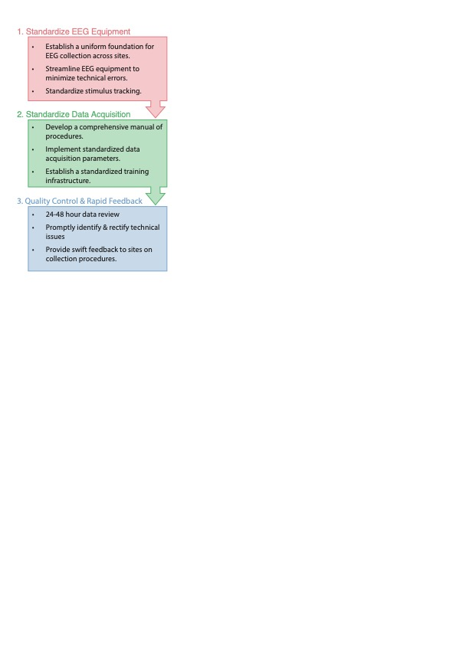

**Figure 1.** Schematic diagram illustrating the structured three phased approach used to integrate EEG data collection into IBIS.

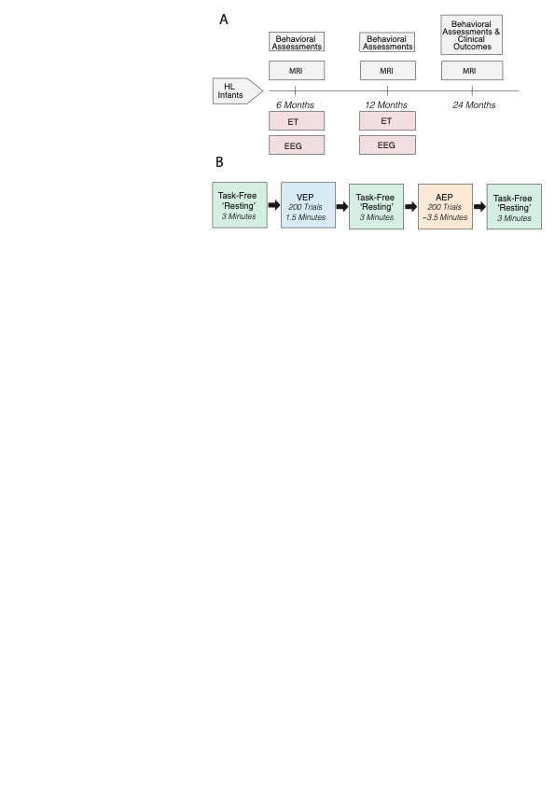

**Figure 2.** Schematics figures detailing A) The IBIS protocol, with new additions (EEG and eye tracking) shaded in red, and B) the paradigm specific protocol for EEG recordings.

|  |  |  |  |  |  |  |  |  |  |  |  |  |  |  |  |  |  |  |  |  |  |  |  |  |  |
| --- | --- | --- | --- | --- | --- | --- | --- | --- | --- | --- | --- | --- | --- | --- | --- | --- | --- | --- | --- | --- | --- | --- | --- | --- | --- |
| |  |  |  |  | | --- | --- | --- | --- | | Site | Amplifier (Net Amps) | Sampling Rate (Hz) | Cap Montage | | A | 400 series | 1000 | 129 | | B | 400 series | 1000 | 129 | | C | 400 series | 1000 | 129 | | D | 400 series | 1000 | 65 | | E | 300 series | 500 | 129 |  A | B 1. Standardized IBIS Laptop  2. Integrated photocell for monitoring visual stimuli  3. Auxiliary connection transmits auditory timing from laptop to AV device  4. AV Device relays stimulus timing to DAC  5. Soundbar for auditory stimuli  6. Guidelines for pre-session laptop checks |

# Figure 3. A) Site-specific EEG system details B) Standardized laptop implemented across sites.

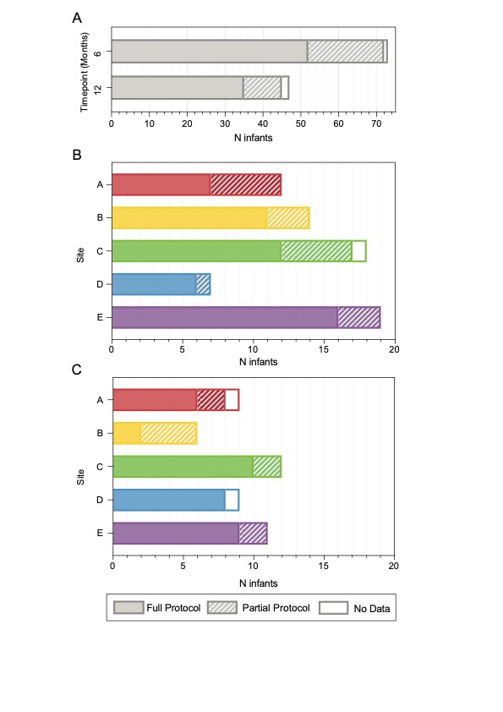

**Figure 4.** EEG Protocol Completion Rates Across Sites and Time Points. (A) Total protocol completion rates aggregated across all five sites at 6 and 12 months. (B) Protocol completion rates broken down by site for the 6-month time point. (C) Protocol completion rates broken down by site for the 12-month time point.

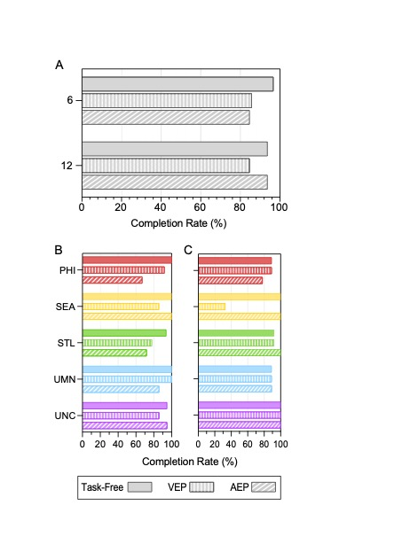

**Figure 5.** Paradigm-Specific EEG Completion Rates Across Sites and Time Points. (A) Completion rates for Task-Free, AEP, and VEP paradigms aggregated across all five sites at 6 and 12 months. (B-C) Detailed completion rates for each paradigm, broken down by individual site at the B) 6-month, and (C) 12-month timepoint.

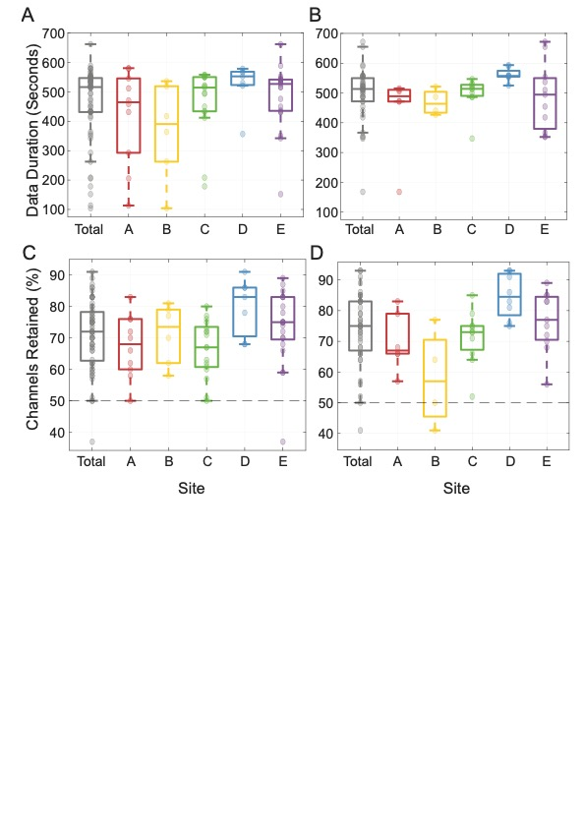

**Figure 6.** A-B) Box plots showing the retained data duration (in seconds) at each site, with a total average plotted in gray for A) 6 and B) 12 months. C-D) Box plots showing the proportion of channels retained at each site, with a total average plotted in gray for C) 6 and D) 12 months.

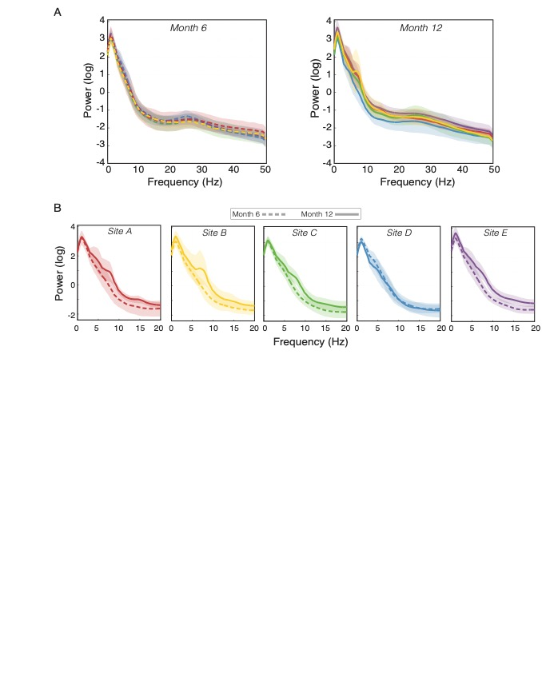

**Figure 7.** Power Spectral Densities (PSDs) for 6-month and 12-month EEG data, averaged across all scalp channels. Shaded regions represent 95% confidence intervals. A) Overlaying PSDs from each site reveals high consistency in signal characteristics at both 6- and 12-month timepoints. B) PSDs show consistent age-related changes in signal characteristics between 6 and 12 months at each site, aligning with anticipated developmental trends.

**Tables**

**Table 1.** Demographic characteristics of the interim sample, collapsed across sites. While there is partial overlap between the 6- and 12-month samples, it is not complete. As of January 1st, 2023, 39 infants had participated in both their 6- and 12-month EEG sessions. Additionally, 8 infants were enrolled at 12 months, having been unable to participate earlier due to the COVID-19 pandemic. The remaining infants in the sample either had not reached the age of 12 months (n = 15) or missed their 12-month EEG for various reasons (n = 19). For more detailed information, please refer to the supplementary material.

|  |  |  |  |  |
| --- | --- | --- | --- | --- |
|  | **6 Months**  *N = 73* | | **12 Months**  *N = 47* | |
|  | **n** | **Percent** | **n** | **Percent** |
| **Gender** |  |  |  |  |
| Female | 28 | 38.36% | 18 | 38.30% |
| Male | 45 | 61.64% | 29 | 61.70% |
| **Ethnicity** |  |  |  |  |
| Hispanic | 22 | 30.14% | 14 | 29.79% |
| Non-Hispanic | 51 | 69.86% | 33 | 70.21% |
| **Race** |  |  |  |  |
| White | 51 | 69.86% | 31 | 65.96% |
| Black | 3 | 4.11% | 3 | 6.38% |
| Asian | 3 | 4.11% | 3 | 6.38% |
| More than one race | 4 | 5.48% | 3 | 6.38% |
| Unknown or not reported | 12 | 16.44% | 7 | 14.89% |
| **Family Income** |  |  |  |  |
| <25K | 5 | 6.85% | 2 | 4.26% |
| 25-35K | 5 | 6.85% | 3 | 6.38% |
| 35-50K | 5 | 6.85% | 4 | 8.51% |
| 50-75K | 13 | 17.81% | 7 | 14.89% |
| 75-100K | 7 | 9.59% | 7 | 14.89% |
| 100-150K | 10 | 13.70% | 4 | 8.51% |
| 150-200K | 10 | 13.70% | 10 | 21.28% |
| >200K | 9 | 12.33% | 5 | 10.64% |
| Unknown or not reported | 9 | 12.33% | 5 | 10.64% |

**Table 3.** Completion rates for the full EEG protocol, as well as paradigm-specific completion rates, at each timepoint. ‘Full Protocol’ describes participants who completed all 5 EEG blocks. Task-Free, AEP and VEP numbers reflect participants who engaged in a minimum of one block for the respective paradigms.

|  |  |  |  |  |  |  |
| --- | --- | --- | --- | --- | --- | --- |
| 6 Months | | | | | | |
|  |  | Total Sample | Full Protocol | Task-Free | VEP | AEP |
| Site A | n | 12 | 7 | 12 | 11 | 8 |
| % |  | 58.33% | 100% | 91.67% | 66.67% |
| Site B | n | 14 | 11 | 14 | 12 | 14 |
| % |  | 78.57% | 100% | 85.71% | 100% |
| Site C | n | 18 | 12 | 17 | 14 | 13 |
| % |  | 66.66% | 94.44% | 82.35% | 76.47% |
| Site D | n | 7 | 6 | 7 | 7 | 6 |
| % |  | 85.71% | 100% | 100% | 85.71% |
| Site E | n | 22 | 16 | 21 | 19 | 21 |
| % |  | 72.73% | 95.45% | 90.48% | 100% |
| Total | n | 73 | 52 | 71 | 63 | 62 |
| % |  | 71.23% | 97.260% | 88.73% | 87.32% |
|  |  |  |  |  |  |  |
|  |  |  |  |  |  |  |
| 12 Months | | | | | | |
|  |  | Total Sample | Full Protocol | Task-Free | VEP | AEP |
| Site A | n | 9 | 6 | 8 | 8 | 7 |
| % |  | 66.67% | 88.89% | 88.89% | 77.78% |
| Site B | n | 6 | 2 | 6 | 2 | 6 |
| % |  | 33.33% | 100% | 33.33% | 100% |
| Site C | n | 12 | 10 | 11 | 11 | 12 |
| % |  | 83.33% | 91.67% | 91.67% | 100% |
| Site D | n | 9 | 8 | 8 | 8 | 8 |
| % |  | 88.89% | 88.89% | 88.89% | 88.89% |
| Site E | n | 11 | 9 | 11 | 11 | 11 |
| % |  | 81.82% | 100% | 100% | 100% |
| Total | n | 47 | 35 | 44 | 40 | 44 |
| % |  | 74.47% | 93.62% | 85.11% | 93.62% |

**Table 4.** Quality metrics for task-free data. This table presents the metrics used to assess data quality, the absolute data duration (in seconds), and the percentage of channels retained post-cleaning. Values are described individually for each site, with the average across sites presented as ‘Total.’

|  |  |  |  |  |
| --- | --- | --- | --- | --- |
|  | **Month 6** | | **Month 12** | |
| Site | Duration Retained (Seconds) | Channels Retained (%) | Duration Retained (Seconds) | Channels Retained  (%) |
|  | Mean (SD)  [Range] | Mean (SD)  [Range] | Mean (SD)  [Range] | Mean (SD)  [Range] |
| Site A | 418.95 (161.85)  [113.32-580.63] | 67.3 (9.98)  [50-83] | 440.45 (134.89)  [167.90-515.10] | 69.83 (9.54)  [57-83] |
| Site B | 367.17 (163.94)  [104.04-536.26] | 71.17 (9.50)  [58-81] | 468.91 (43.29) [426.93-521.37] | 58 (15.81)  [41-77] |
| Site C | 469.34 (114.55)  [178.63-558.32] | 66.71 (8.96)  [50-80] | 499.94 (54.01) [347.03-546.84] | 71.55 (8.61)  [52-85] |
| Site D | 524.93 (77.11)  [356.67-578.56] | 80 (9.07)  [68-91] | 561.44 (21.62) [525.02-593.59] | 84.75 (7.23)  [75-93] |
| Site E | 485.78 (107.02)  [152.05-662.18] | 73.48 (11.75)  [37-89] | 487.98 (112.29) [352.32-671.80] | 76.64 (9.71)  [56-89] |
| Total | 463.07 (126.34)  [104.04-662.18] | 71.10 (10.83)  [37-91] | 496.93 (89.40) [167.90-671.80] | 73.98 (11.82)  [41-93] |

**Supplement**

***EEG Data Processing & Artifact Removal:***

This preliminary analysis prioritized an unbiased quality assessment over specific data analysis needs. Offline data processing was performed using EEGLAB (Delorme and Makeig 2004) and custom MATLAB scripts (The MathWorks, Inc., 2022a). Specifically, we used a general amplitude-based detection algorithm to remove artifacts consistently, rather than using more sophisticated measures that vary in their aggressiveness based on the quality of the data collected for each infant (e.g., artifact subscale reconstruction, Chang et al., 2018). While artifact removal can vary depending on the specific metric under study (power, coherence, connectivity, etc), our objective amplitude-based approach serves as a general benchmark for EEG data quality. Data were imported into eeglab and filtered (1-50 Hz). Continuous data were examined for artifacts using the erplab toolbox functon *pop_continuousartdet*, implemented in eeglab (Lopez-Calderon & Luck, 2014; Delorme and Makeig 2004). First, any channels that deviated +/- 600 *µ*V for more than 5% of an infant’s total resting recording, or data segments where >5% of channels deviated +/- 600 *µ*V were removed. After removing channels and data segments contaminated by large artifacts, continuous EEG data then underwent a second stage of cleaning to remove channels that deviated +/- 200 *µ*V for more than 5% of an infant’s total resting recording, or data segments where >5% of channels deviated +/- 200 *µ*V.

Plotting the power spectral density derived from task-free EEG recordings. Before generating these plots, we processed the artifact-free data further. We applied Independent Component Analysis (ICA) and, using *iclabel*, discarded any components where the primary source was unlikely to be neural. To ensure uniformity across all sites, we interpolated the data to a consistent 64-channel montage and reduced its sampling rate to 500 Hz. Power was computed using the *pwelch* function implemented in MATLAB, with two-second windows and a 50% overlap. Recognizing varied data duration among participants, we employed a permutation-based approach to calculate power. Specifically, we derived power from a random 60-second segment of the EEG, repeating this 500 times for each participant, with the average of all permutations representing the final power for each individual. Plotted PSDs represent average power across all channels.

***Evaluating and Strategizing Based on Stages of Data Loss:***

The hierarchical data evaluation in this paper offers a comprehensive perspective on our study's strengths and potential challenges, guiding us in enhancing protocol adherence, refining technical procedures, and setting appropriate expectations for usable data output. Specifically, through an evaluation of task-free data retention across our research process, from data collection to artifact removal, we identified key stages of data loss, their causes, and their implications for data integrity. Data loss was defined as data that was unable to be utilized in analysis due to incomplete paradigm completion, technical errors, or excess artifact requiring more than 50% of channels to be removed or fewer than 60 seconds of clean data able to be retained. We saw consistent overall data loss across both study timepoints (17.81% at 6 months and 17.02% at 12 months) that were relatively low compared to data loss rates reported in other studies which are as high as 50% (Cuevas et al., 2014).

From our dataset, only two 6-month and one 12-month files (3 out of 120 total files, or 2.5%) were discarded due to infant related factors or technical errors. We further categorized data loss sources based on stage: during the session, post-session file review, and at final data quality control checks. Session-level data loss was minimal, suggesting our standardized equipment and protocol effectively accommodated the participants, with most able to complete the sessions without major interruptions. This was reinforced by the minor disruptions due to equipment malfunctions. Only three sessions had equipment-related setbacks, emphasizing the value of our preliminary test block that preemptively caught such concerns before infant participation. Furthermore, at the final data quality control stage, only two sessions were discarded due to failing to retain more than half the channels after artifact removal.

Our preliminary analysis highlights external environmental noise interference as the main source of data loss. Specifically, despite successful initial data capture, several files were identified as unusable due to disruptions affecting the integrity of the recorded data, providing insight into potential systematic problems. The sources of post-session data loss can generally be categorized into internal issues (file corrupted, recording error) or external sources (large mains line noise). We saw higher rates of external issues (compared to internal) at 6 months, but a more even distribution of internal vs external issues at 12 months. A detailed examination revealed that out of the 14 files lost during the post-session review, four were swiftly identified and rectified, ensuring they did not jeopardize subsequent recordings. Conversely, ten files, particularly from the Seattle site (8 at 6 months, 2 at 12 months), were compromised due to persistent noise issues that were beyond our remedial reach and impacted multiple recordings. Recognizing this, we will take future efforts to preemptively detect and address noise issues, integrating quantitative metrics of 60 Hz noise levels during file reviews. Continuous monitoring of these rates will facilitate early detection of emerging noise concerns, enabling us to proactively mitigate potential data losses.

**References**

*American Psychiatric Association. (2013). Diagnostic and Statistical Manual of Mental Disorders (DSM-5). Washington, DC: American Psychiatric Association Publishing.* (n.d.).

Cuevas, K., Cannon, E. N., Yoo, K., & Fox, N. A. (2014). The Infant EEG Mu Rhythm: Methodological Considerations and Best Practices. *Developmental Review : DR*, *34*(1), 26. https://doi.org/10.1016/J.DR.2013.12.001

Girault, J. B., & Piven, J. (2020). The neurodevelopment of autism from infancy through toddlerhood. *Neuroimaging Clinics of North America*, *30*(1), 97. https://doi.org/10.1016/J.NIC.2019.09.009

Hazlett, H. C., Gu, H., Munsell, B. C., Kim, S. H., Styner, M., Wolff, J. J., Elison, J. T., Swanson, M. R., Zhu, H., Botteron, K. N., Collins, D. L., Constantino, J. N., Dager, S. R., Estes, A. M., Evans, A. C., Fonov, V. S., Gerig, G., Kostopoulos, P., McKinstry, R. C., … Piven, J. (2017). Early brain development in infants at high risk for autism spectrum disorder. *Nature 2017 542:7641*, *542*(7641), 348–351. https://doi.org/10.1038/nature21369

Levin, A. R., Naples, A. J., Scheffler, A. W., Webb, S. J., Shic, F., Sugar, C. A., Murias, M., Bernier, R. A., Chawarska, K., Dawson, G., Faja, S., Jeste, S., Nelson, C. A., McPartland, J. C., & Şentürk, D. (2020). Day-to-Day Test-Retest Reliability of EEG Profiles in Children With autism spectrum disorder and Typical Development. *Frontiers in Integrative Neuroscience*, *14*. https://doi.org/10.3389/FNINT.2020.00021

Shen, M. D., Kim, S. H., McKinstry, R. C., Gu, H., Hazlett, H. C., Nordahl, C. W., Emerson, R. W., Shaw, D., Elison, J. T., Swanson, M. R., Fonov, V., Gerig, G., Dager, S., Botteron, K. N., Paterson, S., Schultz, R. T., Evans, A. C., Estes, A., Zwaigenbaum, L., … Styner, M. (2017). Increased Extra-axial Cerebrospinal Fluid in High-Risk Infants Who Later Develop autism. *Biological Psychiatry*, *82*(3), 186–193. https://doi.org/10.1016/J.BIOPSYCH.2017.02.1095

Shen, M. D., Nordahl, C. W., Li, D. D., Lee, A., Angkustsiri, K., Emerson, R. W., Rogers, S. J., Ozonoff, S., & Amaral, D. G. (2018). Extra-axial cerebrospinal fluid in high-risk and normal-risk children with autism aged 2-4 years: a case-control study. *The Lancet. Psychiatry*, *5*(11), 895–904. https://doi.org/10.1016/S2215-0366(18)30294-3

Shen, M. D., Nordahl, C. W., Young, G. S., Wootton-Gorges, S. L., Lee, A., Liston, S. E., Harrington, K. R., Ozonoff, S., & Amaral, D. G. (2013). Early brain enlargement and elevated extra-axial fluid in infants who develop autism spectrum disorder. *Brain : A Journal of Neurology*, *136*(Pt 9), 2825–2835. https://doi.org/10.1093/BRAIN/AWT166

Shen, M. D., Swanson, M. R., Wolff, J. J., Elison, J. T., Girault, J. B., Kim, S. H., Smith, R. G., Graves, M. M., Weisenfeld, L. A. H., Flake, L., MacIntyre, L., Gross, J. L., Burrows, C. A., Fonov, V. S., Louis Collins, D., Evans, A. C., Gerig, G., McKinstry, R. C., Pandey, J., … Piven, J. (2022). Subcortical Brain Development in autism and Fragile X Syndrome: Evidence for Dynamic, Age- and Disorder-Specific Trajectories in Infancy. *American Journal of Psychiatry*, *179*(8), 562–572. https://doi.org/10.1176/APPI.AJP.21090896/ASSET/IMAGES/LARGE/APPI.AJP.21090896F5.JPEG

Stets, M., Stahl, D., & Reid, V. M. (2012). A meta-analysis investigating factors underlying attrition rates in infant ERP studies. *Developmental Neuropsychology*, *37*(3), 226–252. https://doi.org/10.1080/87565641.2012.654867

Van Noordt, S., Desjardins, J. A., Huberty, S., Abou-Abbas, L., Webb, S. J., Levin, A. R., Segalowitz, S. J., Evans, A. C., & Elsabbagh, M. (2020). EEG-IP: an international infant EEG data integration platform for the study of risk and resilience in autism and related conditions. *Molecular Medicine (Cambridge, Mass.)*, *26*(1). https://doi.org/10.1186/S10020-020-00149-3

Zwaigenbaum, L., & Penner, M. (2018). Autismspectrum disorder: advances in diagnosis and evaluation. *BMJ (Clinical Research Ed.)*, *361*. https://doi.org/10.1136/BMJ.K1674